Etch Your Name into Amate House’s Prayer Garden!
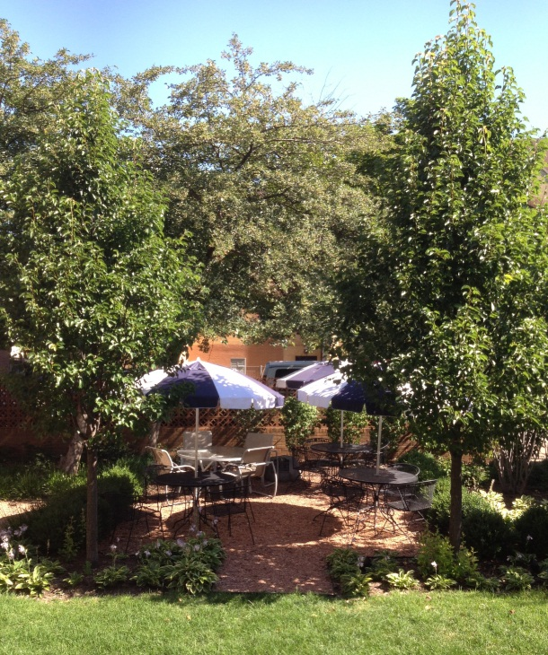
ORDERING INSTRUCTIONS
- Orders will be accepted as long as space is available
- If you wish to purchase more than one brick or would like your brick placed next to another, these orders must be submitted together. Every effort will be made to accommodate your request.
- Your message must fit within the spaces provided on each brick size.
- All text will be standard size, font and style.
- Messages will be centered automatically. The use of upper and lower case letters is permitted.

To order your bricks today, fill out the form below and mail with your payment to:
Amate House
3600 S. Seeley Ave.
Chicago, IL 60609
------------------------------------------------------------------------------------------------------------------------------------------
_________________________________________________
Purchaser’s Name
_____________________________________
Street Address
_________________________________________________
City State Zip
_________________________________________________
Daytime Phone
_________________________________________________
Email address

Payment Method

___ My check is enclosed, payable to Amate House

___ Please charge my credit card:
___ MasterCard ___ VISA
Account # ____________________________________________
Exp. ______ /________
Signature______________________________________________

SAMPLE
M | e | g | h | a | n |  | M | c | C | a | r | t | h | y
N | o | r | t | h |  | H | o | u | s | e |  | A | l | u | m
2 | 0 | 0 | 7 | - | 2 | 0 | 0 | 8

____4”x8” Brick: $100
(3 Lines, Maximum 20 spaces per line)

____8”x8” Brick: $180
(6 Lines, Maximum 20 spaces per line)

