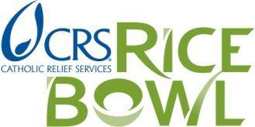

2018 CRS Rice Bowl Remittance Form

Please submit this form and mail all checks to CRS Rice Bowl:

Catholic Relief Services - CRS Rice Bowl
Archdiocese of Chicago
3525 S. Lake Park Avenue
Chicago, IL 60653

Name of Parish or School: _____________________________________________________________________

Address: __________________________________________ City/State:_______________________________

Zip: ___________ Phone: ____________________________ Fax: __________________________________

CRS Rice Bowl Coordinator’s Name: __________________________________________________________

Coordinator’s Email: _______________________________ Coordinator’s Phone: ________________________

Number of participating families: __________________ Total amount submitting to CRS: $_________________

Please remit 100% of Rice Bowl donation proceeds. 75% of the total funds received will support CRS development projects throughout the world, while 25% will fund local programs and initiatives that animate the values of CRS in the Archdiocese of Chicago. To learn more, visit www.chicagopeaceandjustice.org/crsricebowl

2019 CRS Rice Bowl Materials Order Form (INDICATE NUMBERS FOR EACH)

Rice Bowls English _______________ Spanish _______________

Coordinator Guides (bilingual) _______________

Rice Bowl DVD _______________

Educators Guides English _______________ Spanish _______________

Posters (bilingual) _______________

