OPTION 1
2021 Missionary Cooperation Plan
We will hold the Missionary Cooperation Plan collection on the weekend of August 7-8, 2021. Missionaries are not able to be with us due to the global pandemic. Instead, we are learning about the 104 mission causes that will benefit from the collection virtually. Here is information about just three of these groups:
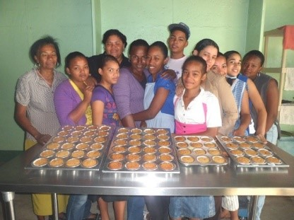
The members of the Congregation of the Holy Spirit go to those who haven’t heard the message of the Gospel and whose needs are greatest. Spiritan Fr. Donald McEachin ministers at a parish in San Juan de la Maguana, Dominican Republic. To address rampant unemployment, Fr. Don established a job training school. St. Michael the Archangel Technical Professional School offers courses in computer data processing, word processing, sewing, beauty salon training and baking. It is now one of the top three professional training schools in the Dominican Republic, and the only one that does not charge tuition.
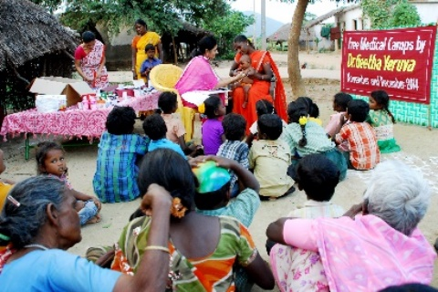
The Foundation for Children in Need is a Catholic lay organization based in Arlington Heights, Illinois. Dr. Geetha Yeruva and Mr. Tom Chitta established it to work in the interior villages of Southern India. The foundation has built several schools, boarding homes, a community health center and a home for the elderly. They provide free medical check-ups and medicine to thousands of people. At the heart of the foundation’s mission is education. Providing an education to an individual changes the trajectory of a person’s life, as do the health education classes that Dr. Geetha conducts for teenage girls.
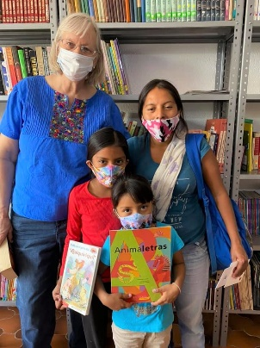
The Sisters of St. Francis, with their Motherhouse in Tiffin, Ohio work to spread the Gospel and strengthen the Catholic faith through ministries of evangelization, pastoral care, education, prison ministry, emergency services and health care. In their Cuernavaca, Mexico mission, poverty is widespread. It is common to see children as young as five years old selling gum or trinkets so they can have food for the day. Not long ago, one sister visited a home where the baby was sleeping in a cardboard box. She asked why their beds were gone; the family said they needed to sell the beds so they could buy food. The Sisters provide various forms of assistance to families in need. It could be anything from a meal to a pair of shoes to a small interest-free loan. They also offer children the opportunity to receive educational support and mentoring.
Please pray for these and more mission causes sharing the Bread of Life with communities around the world. The local churches cannot support these ministries by themselves. So, if you are able, please place cash or a check, made out to our parish, in the second collection basket. Or you may give online, using a credit card at www.WeAreMissionary.org/give. Each donation will be distributed evenly to all 104 participating mission causes.
OPTION 2
2021 Missionary Cooperation Plan
The Missionary Cooperation Plan collection will take place on the weekend of August 7-8, 2021. Missionary speakers cannot be with us due to the global pandemic. Instead we are learning about the 104 beneficiary mission causes virtually. Here is some information about just three groups:
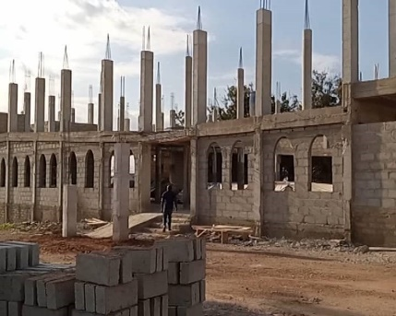
The Diocese of Obuasi, Ghana is predominantly a rural diocese with a poor road network and the people are peasant farmers who live from hand to mouth. While the diocese has 41 parishes, there are also over 400 mission churches located in remote communities. The diocese is not yet self-sustaining as the many costs of evangelization and pastoral ministry are significant:
- The formation and training of each seminarian costs $1,500
- Training each catechists costs $500
- Training each Sunday School teacher costs $200
- Drilling each well for mission churches costs $5,000
- To repair the roof of a mission church costs at least $10,000. Too many mission churches celebrate Mass under a tree!
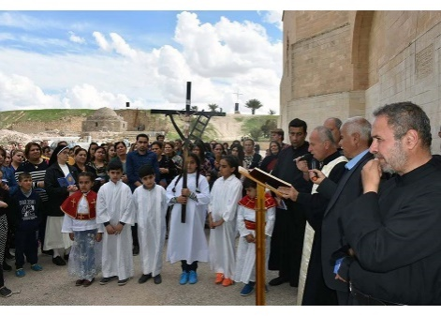
The Institute of the Incarnate Word is a men’s religious congregation present in 40 countries. Incarnate Word priests provide homes for the poor and abandoned children and manage schools and educational institutions in rural areas. One of their most challenging missions is in Iraq. After arriving there in 2010, Fr. Luis Montes became conscious of the never-ending oppression of Christians. There have been roughly twenty attacks per month for many years. Fr. Montes sought to create a Facebook page, “Amigos de Irak” (Friends of Iraq), as a space for prayer, for spreading information about the persecution and to receive donations. Because of this page he has received enough donations to build a refugee camp for Christians in Baghdad now used to celebrate Sunday Mass, pray during weekdays and unite the community.
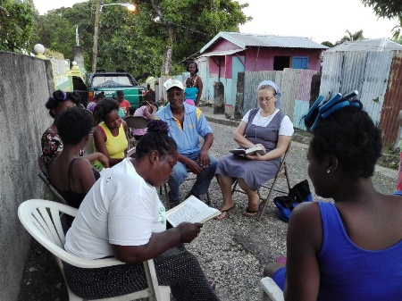
The Holy Spirit Missionary Sisters live and work in over 50 countries. The Sisters work with the poor and marginalized; among those whose life circumstances make it difficult to know and believe in God’s love for them. One particular mission that needs help is in Morant Bay, St. Thomas Civil Parish in Jamaica. Sr. Barbara works with many elderly women, living alone and many younger women with small children that live in small hovels often without electricity, running water and adequate food or medication. Sr. Barbara tries to help with some of their basic needs, such as food or roofing material to keep the rainwater from seeping into their ‘shelter.’ She also devotes considerable time to training local women as catechist assistants to share the Gospel with women and children in the more abandoned areas.
Please pray for these and more mission causes sharing the Bread of Life around the world. The local churches cannot support these ministries by themselves. So, if you are able, please place cash or a check, made out to our parish, in the second collection basket. Or you may give online, using a credit card at www.WeAreMissionary.org/give. Each donation will be distributed evenly to all 104 participating mission causes.

OPTION 3
2021 Missionary Cooperation Plan
The Missionary Cooperation Plan collection weekend is August 7-8, 2021. Missionaries are not able to be with us due to the global pandemic. Instead we will learn about the 104 mission causes that will benefit from the collection virtually. Here is information about just three of these groups:
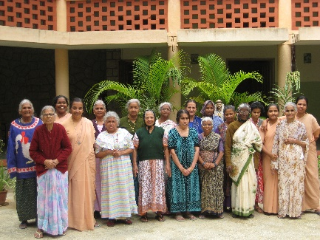
The School Sisters of St. Francis are an international community who, for almost 150 years, strive to be the Face of Jesus for people of all ages and abilities through ministries in education, health care, pastoral care and social services. One particular mission in Bangalore, India includes the Asha Bhavan Home, where elder women who have been abandoned are given a safe place to live with dignity and love. The Sisters provide nourishing food, medical services and compassionate care to about 24 destitute mostly elder women who have been abandoned by their families. Many are bedridden, mentally challenged or extremely fragile in mind and spirit. The sisters provide these women with help and hope, enabling them to regain not only their health, but also their sense of self worth and self respect.
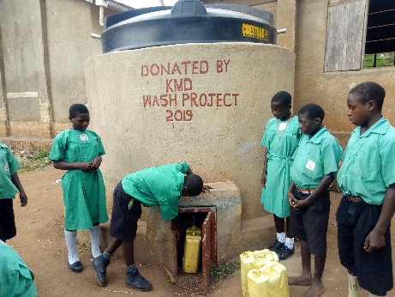
The Diocese of Kiyinda-Mityana is located in a rural region of Uganda. The diocese will soon begin celebrating its 40-year anniversary. One major goal for this year is to provide clean drinking water to all regions. The diocese has already begun to distribute small water containers to various households for the storage of drinking water. As well, the diocese intends to provide poly-fiber tanks to all diocesan Catholic schools. The filters make it safer for consumption as rainwater is a proven source of clean and safe water. Many water sources located in low areas become polluted in the rainy season. This will ensure accessibility to clean and safe water and hygienic practices like frequent washing of hands.
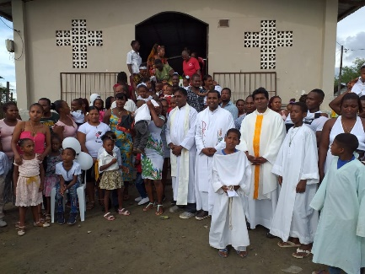
The Missionaries of St. Francis DeSales recently initiated a new mission in Ecuador within the Apostolic Vicariate of Esmeralas. Thousands of Catholics reside in the Vicariate, spread over a wide geographic area with few roads. The people of this region are largely of African or indigenous Indian descent and most do not have the opportunity to practice their faith due to the scarcity of priests and church buildings. The Vicariate is divided into “substations” with many having churches in disrepair with roofs or walls missing or lack of windows that leave the building unsafe. Masses are held in homes where there is little room for the faithful. This has resulted in many people falling away from the faith. In spite of the obstacles, in 2020 the missionaries have baptized 192 children and gave First Communion to an additional 112.
Please pray for these and more mission causes sharing the Bread of Life around the world. The local churches cannot support these ministries by themselves. So, if you are able, please place cash or a check, made out to our parish, in the second collection basket. Or you may give online, using a credit card at www.WeAreMissionary.org/give. Each donation will be distributed evenly to all 104 participating mission causes.

