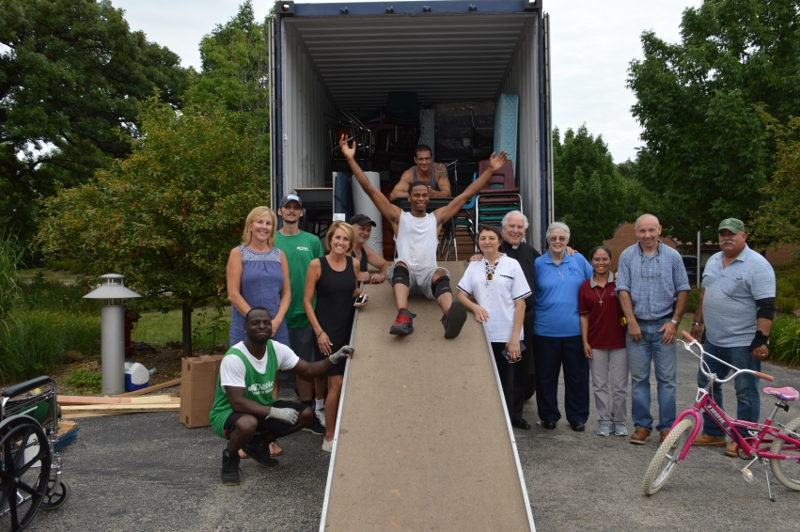
Holy Spirit Missionary Sisters (SSpS) - Sr. Monica Mabel, Sr. Mary Miller, and Sr. Rosalia Galmin with Fr. Robert Heinz (Pastor – St. Norbert Parish – Northbrook) with lay collaborators from the parish loading a shipping container for our mission in Morant Bay, Jamaica
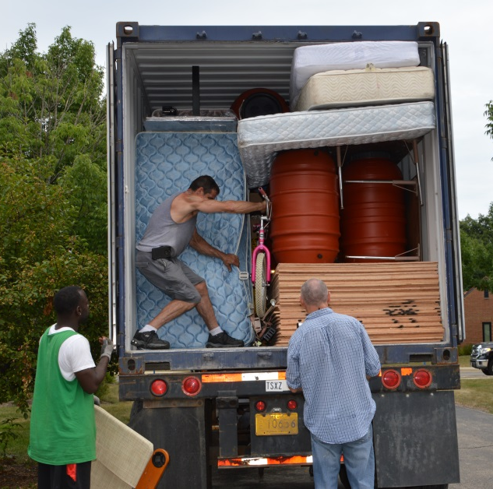
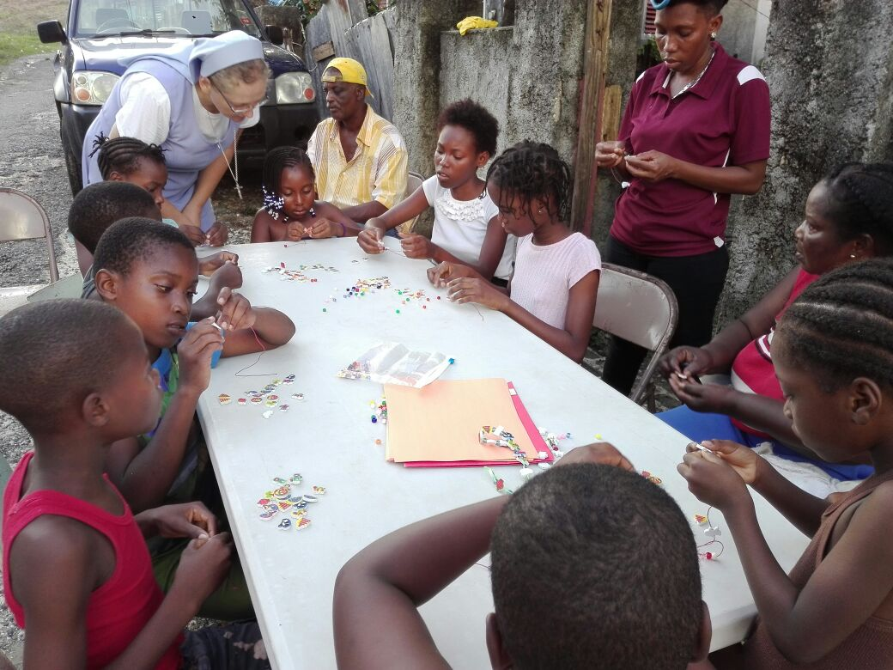
Sr. Barbara Miensopust with children in Bamboo River, Jamaica.
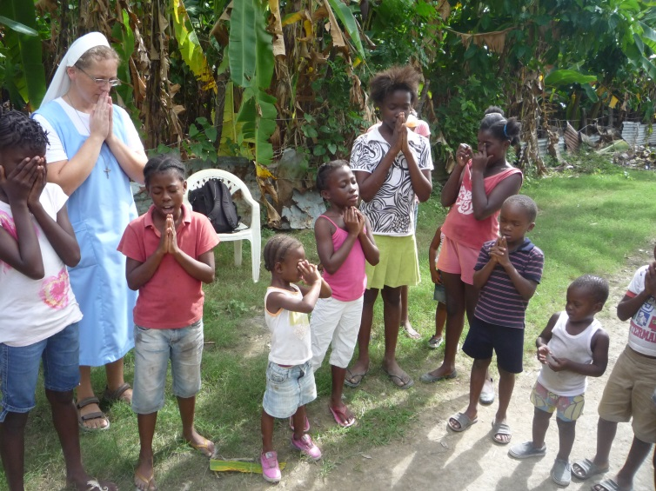
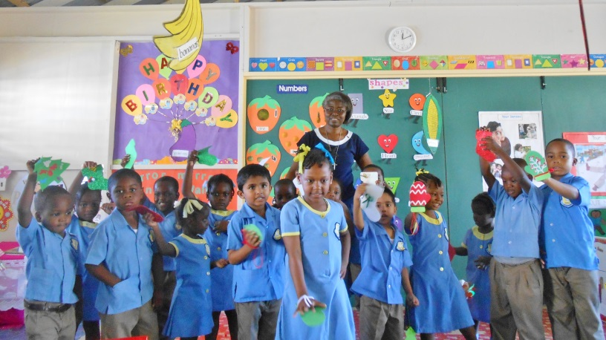

Sr. Theresa Tawiah, SSpS with children at Our Lady of the Assumption School, Morant Bay, Jamaica.

