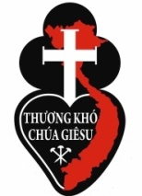 | Passionist Mission Vietnam  Dòng Thuơng Khó Chúa Giêsu 63/12/4 Đường Số 36, KP 8,
Phường Linh Đông, Quận Thủ Đức,
TP Ho Chi Minh, Vietnam
Tel: +84 28 2250 8445, Cell: +84 948 761 621
jefferiesfoale@gmail.com

June 2020
The Harvest is Ready! Training Apostles.

Jesus is alive in Vietnam, and His work is spreading! In fourteen years the Passionist Mission has survived many threats to the Gospel dream in this beautiful but afflicted country. Vietnamese recruits have become a strong team of Passionists, and finally the first of them are out on mission to the poor and deprived. Their idealism and holy energy is an inspiration. An old bishop said to me, "Hurry up and get those young men ordained. The people are waiting for them." With your help we can do it.
We have found ways, even under communist restrictions, to work behind closed doors, forming the church of the future. Foreign priests like me are not allowed to minister in the church. But, they have not stopped us quietly training young Vietnamese men who can be allowed to minister. Besides their busy theology school our seminarians are helping out pastors in every task, in city parishes and in remote and difficult places, on weekends and during the summer break. They are much loved serving the disabled. They befriend everyone.
Seven Vietnamese Passionist seminary graduates have now been ordained. Our first Vietnamese priests are working under supervision in the seminary and in parishes in the remotest locations, lifting up the poor by their loving service. For the Bishop of Can Tho we are running a parish, reaching out to impoverished isolated people and establishing a spiritual centre.
Thirty five more are “in the pipeline” for priesthood. They inspire all they meet. But our income has been largely wiped out while food and other costs are up, and more of the poor depend on us to survive. We have learned to cope with less, but suffering people cannot wait forever. We turn to you for help. Through the Mission Cooperative Plan we can tell our story to the wonderful people in your parish who have shown great generosity even in tough times. Their solidarity will bring joy and life to Vietnam!
Yours sincerely in the Passion of Christ,
Fr Jefferies Foale cp, Passionist Mission Vietnam
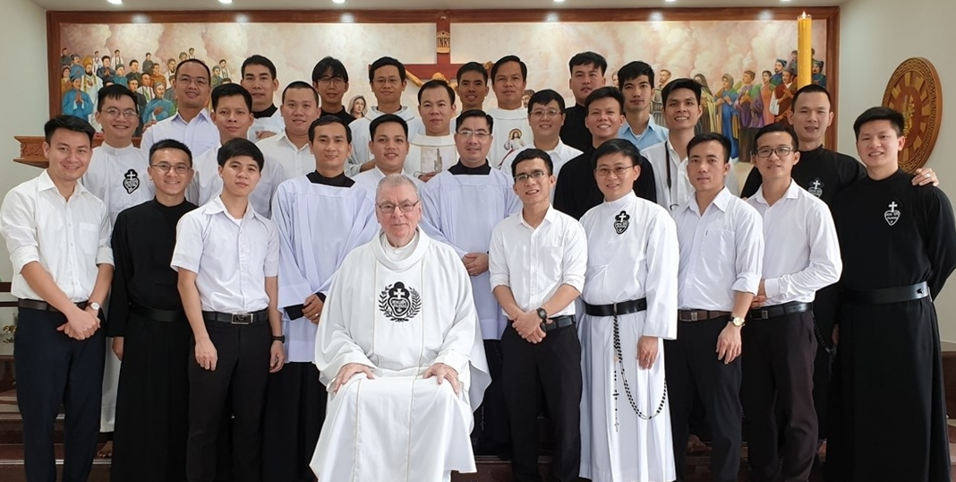
Ready for Mission - and that's me in the middle

