**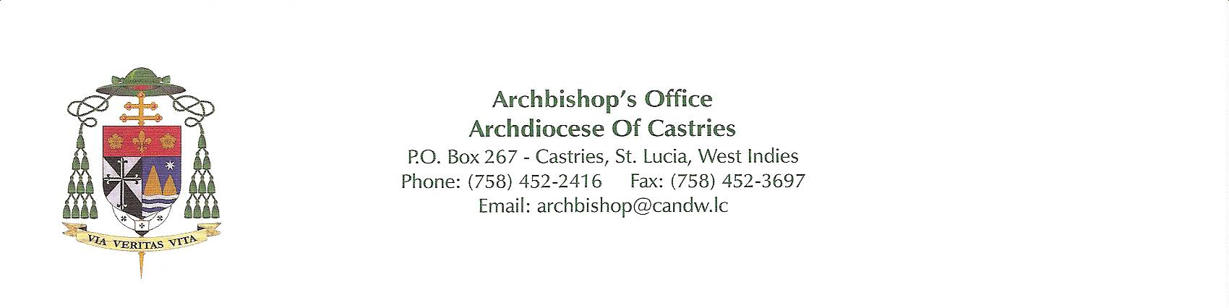****29/06/2020**

**Mission Office Attn: Missionary Cooperation Plan**

**3525 South Lake Park Avenue Chicago, IL 60653, USA.**

**Dear Sir / Madam,**

**I fully support the work of the Dominican Friars of the Province of Nigeria working in Saint Lucia in the Caribbean. Since their arrival in the Archdiocese of Castries six years ago they were assigned to the parish of the Good Shepherd in Babonneau with many Communities within the single parish. Their presence has brought joy to our local Church.**

**The living facility in the parish, the Presbytery, was built to accommodate one priest. It encompasses the Parish Administration and serves as the Pastoral Centre for the parish. Presently there are two priests of the Dominican Order serving in the parish and the accommodation is inadequate. The present situation does not enhance living together in Community. The Building itself is seventy years old and needs urgent repairs and rehabilitation which includes plumbing and electrical wiring. The Friars have been very patient and adapted to the situation in which they found themselves. They have made some minor adaptations over the past six years but much more needs to be done. The time has come to improve the facilities for them and for the parish.**

**We presented a project proposal to Propaganda Fide in Rome and received a grant for US$15,000.00. The parish is working hard with the aim of raising US$20,000.00 locally. The total cost of the project is US$100,000.00. It is obvious that the Project will be accomplished in phases.**

**The Church in Saint Lucia still needs a great deal of financial help for its development and progress. Alone we cannot make it.**

**I know this is a tough time for many of you. Giving now requires greater sacrifice than it has in a long time. With God’s help and yours, the Church in St. Lucia isn’t letting a pandemic stop us from bringing the Gospel to God’s people.**

**Many thanks for your kind consideration and attention. May our Blessed Mother, Mary, and all the Angels smile on you today and always. God bless.**

**Sincerely in Christ**



**+Robert Rivas, O.P.**

**Archbishop of Castries**