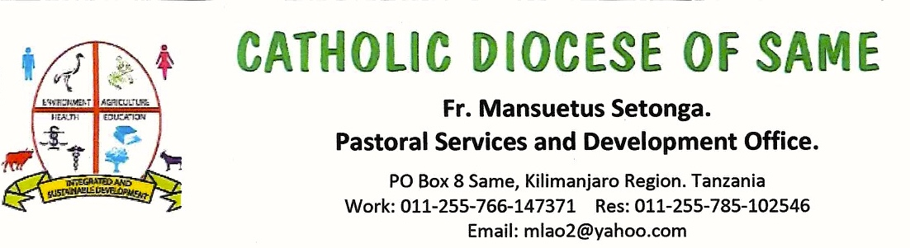
MISSION APPEALS 2020: HOMILY: 2020: Drilling A Well Mwembe Village

- My name is Fr. Mansuetus Setonga from the Catholic Diocese of Same, Tanzania. The Catholic Diocese of Same is situated in Kilimanjaro Region, in the northern part of Tanzania, Africa.

- Population of the Diocese:
The Inhabitants of the Diocese of Same are mainly peasants who practice subsistence agriculture. Due to drought, the Diocese of Same is one of the poorest Dioceses in Tanzania with a per capital income of $608 per year. Life expectancy is 60 years. About 67 % of the population lives in abject poverty (less than a dollar a day).
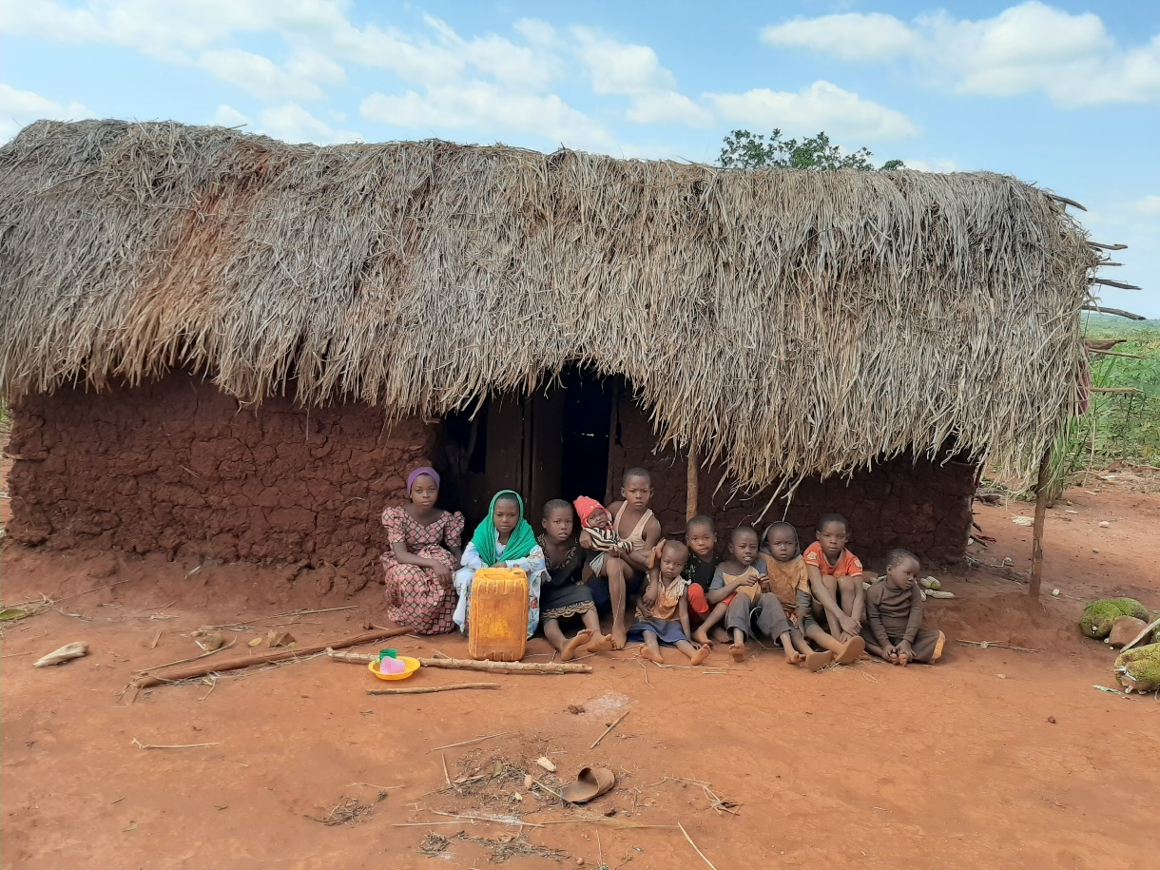
A family of eight children in a house of made thatched with grass
- Problem Statement:
Only 62% of the population has no access to clean water.
Women and children walk an average of 4 hours a day to water ponds which hold rainstorm water during the rainy season. This water is dirty because it is used by people and animals. People use this water for drinking, cooking, and washing. As a result, many people suffer from diarrhea and typhoid.

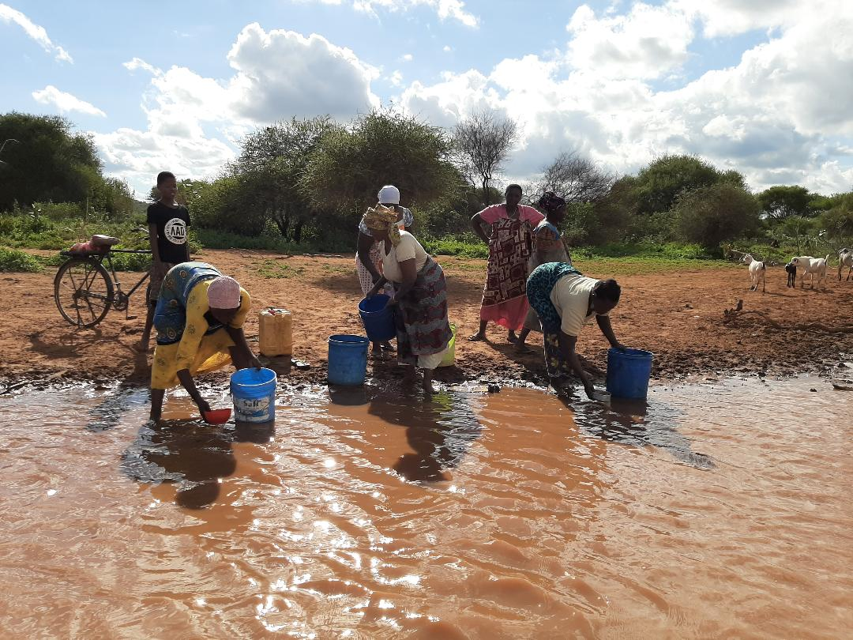

- Expected Results:
When the well is drilled, the following results will happen:
- Clean and safe water will be provided
- Cholera, typhoid and diarrhea will be reduced or even eradicated
- Women will have ample time for economic activities and children will spend more time in schools.
- Death rate will be reduced by 60%

- Experience:
Last year we drilled a well at Mareti village in the Diocese of Same, funded by a women’s group in the Netherlands. The people of Mareti were grateful and there was no more fighting for the water. In one family, the husband took a bath three times the same day as he never believed that now water would continue to be available.

Request:
The people of Mwembe village are requesting an amount of $11,000 for drilling a well at Mwembe village which will serve about 600 families (2,400 people).

Sincerely,

Fr. Mansuetus Setonga
Coordinator of Mission Appeals, Diocese of Same, Tanzania, Africa

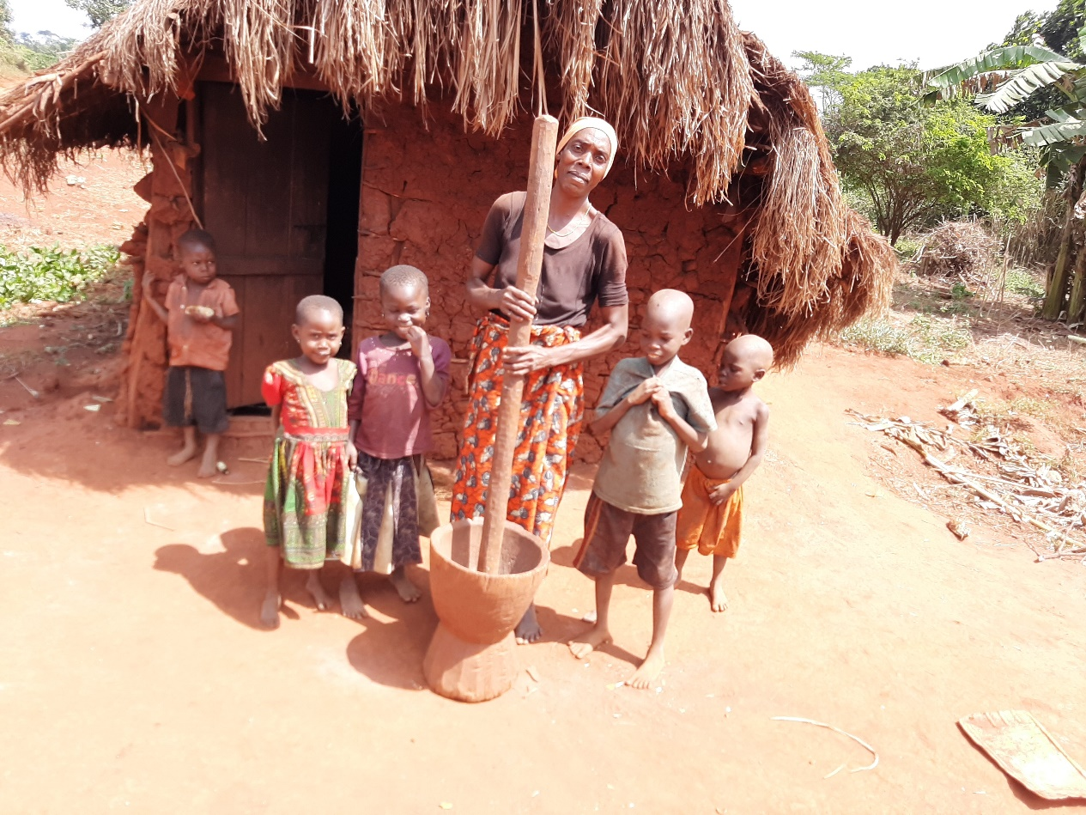

A woman grinding corn-flour.

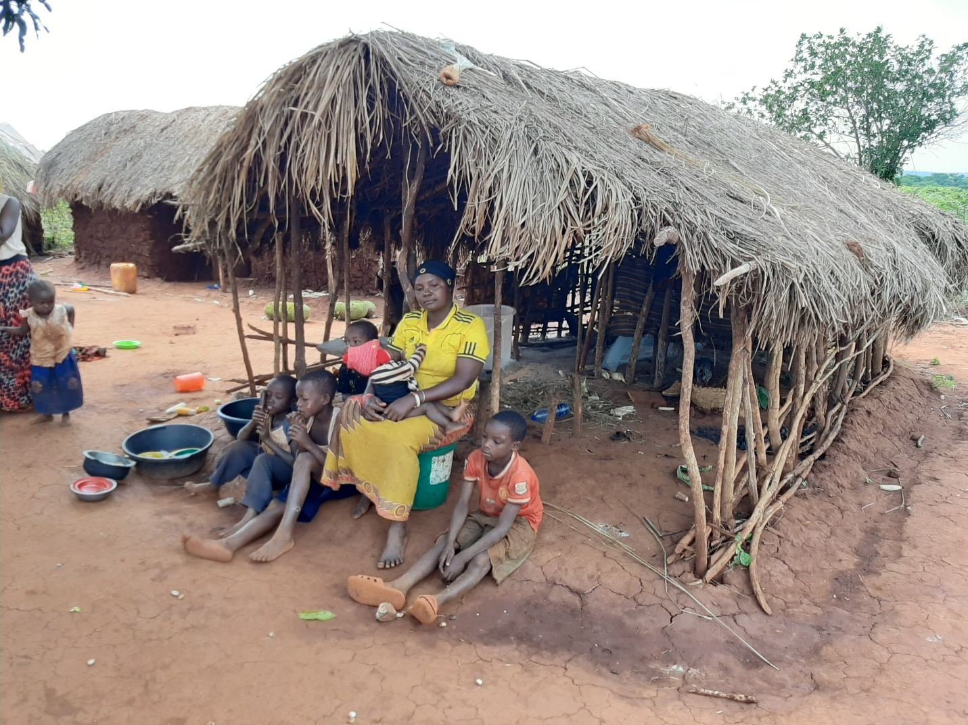

A family of a mother, husband and six children in an insufficient house
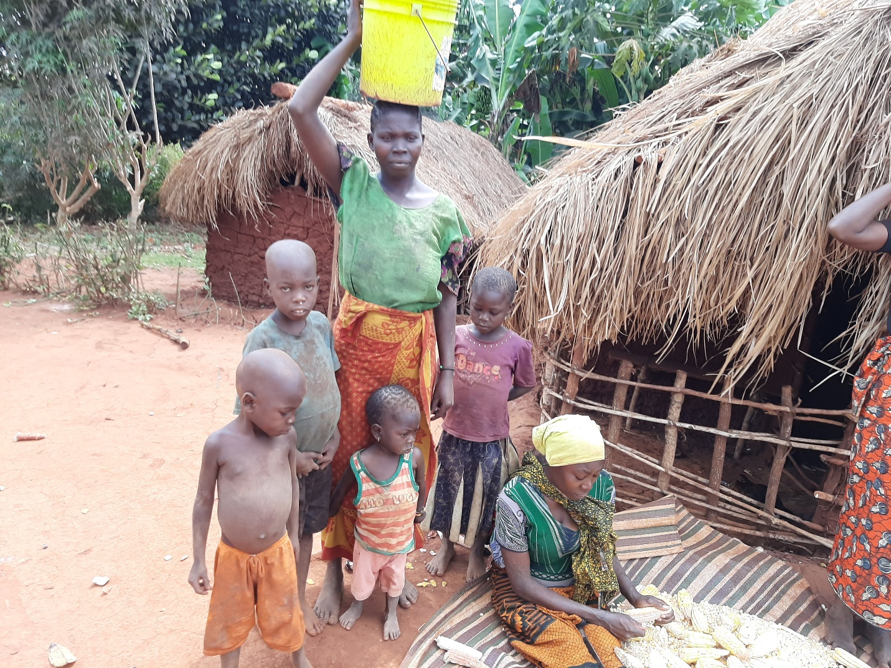

A woman carrying a bucket of water of 18 liters (almost 5-gallons) and another siting preparing corn for cooking

