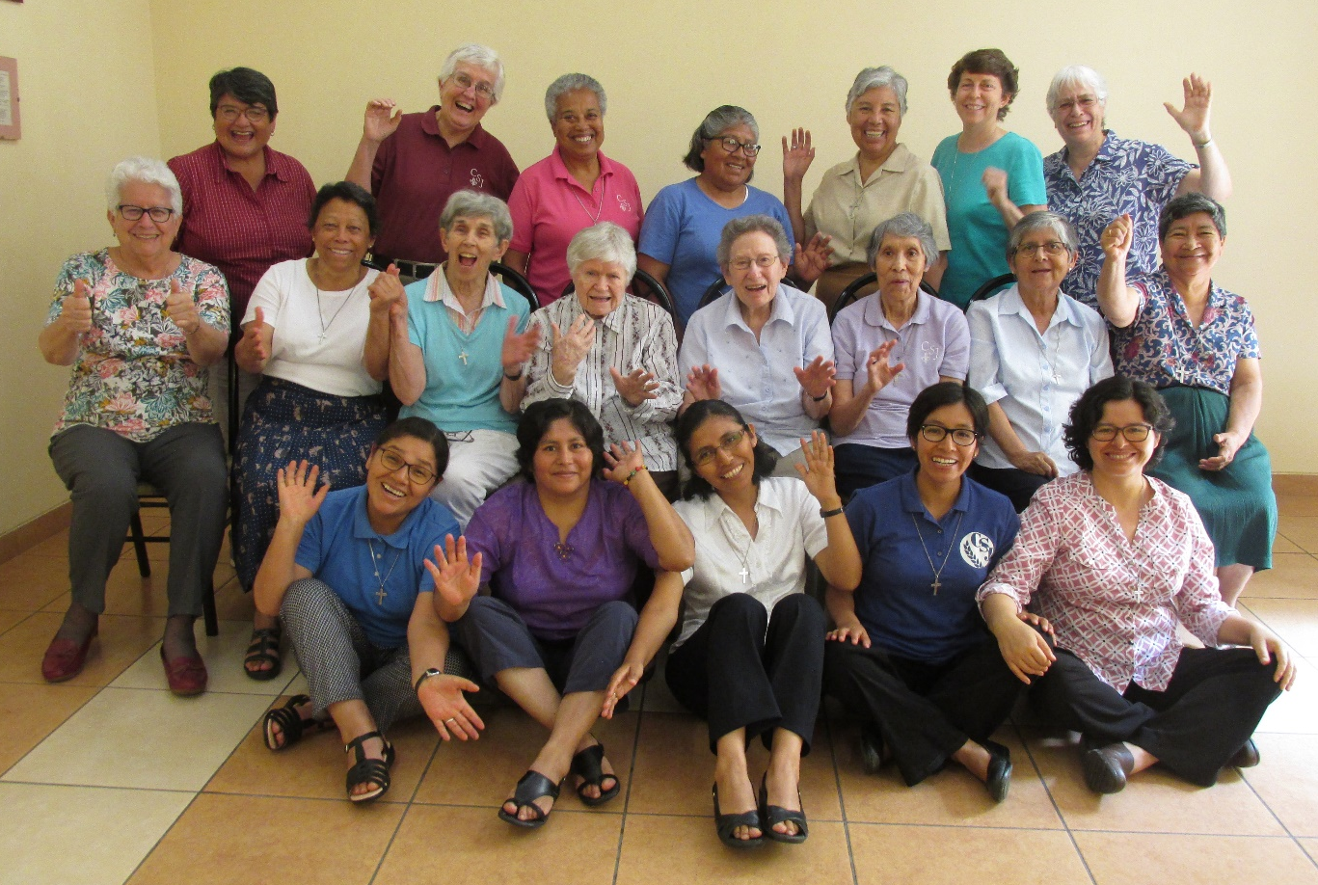
- Sisters of St. Joseph of Carondelet of the Vice Province of Peru
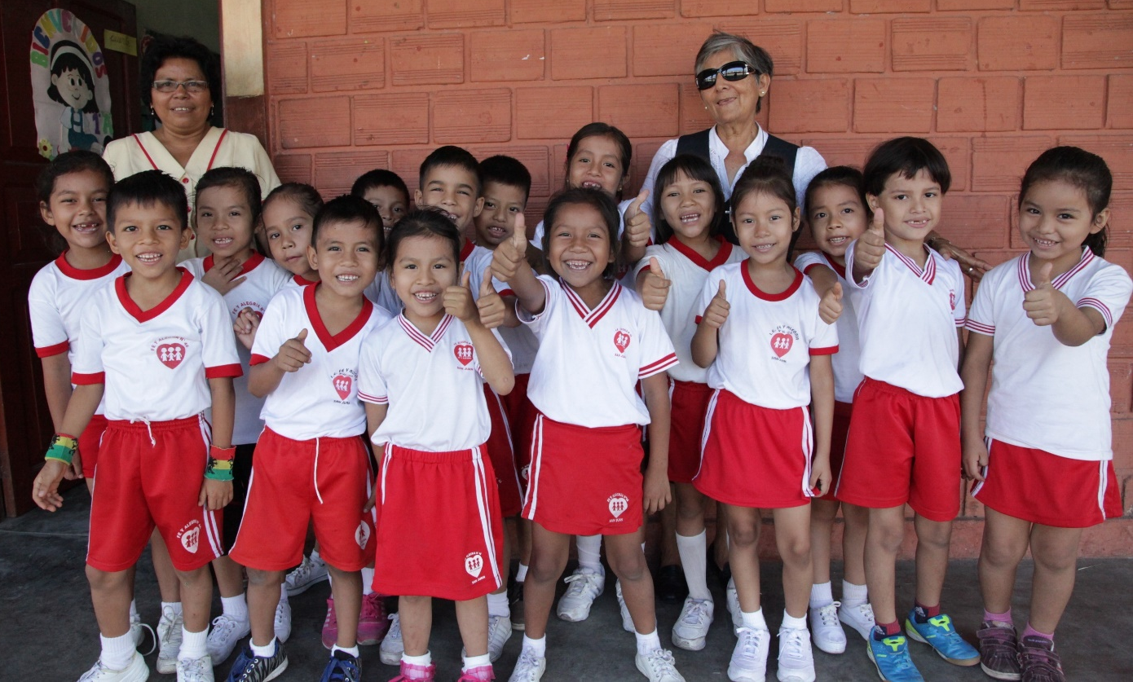
- Sr. Maria Ines with students of Faith and Joy School
- Sister Anne with women of the neighborhood preparing food for people during the pandemic.

4. Sister Zaida visiting elderly woman
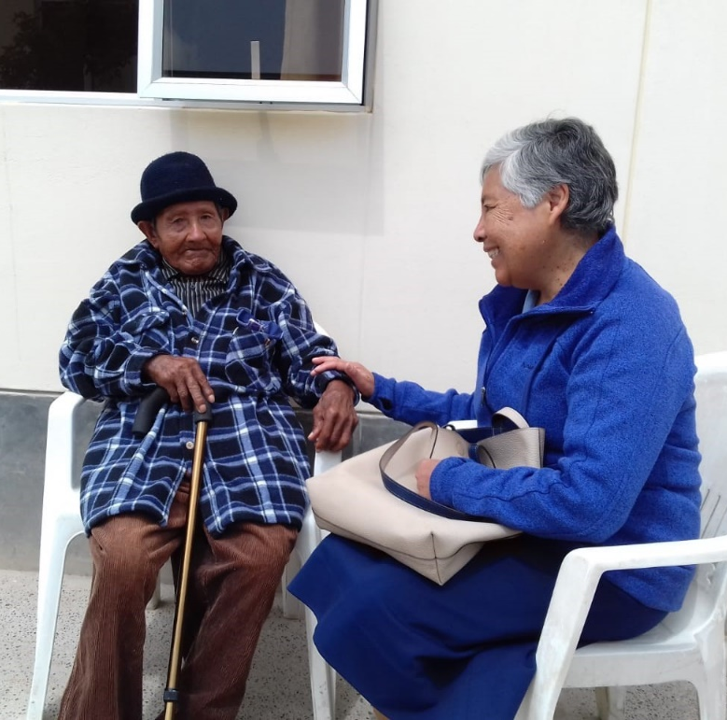

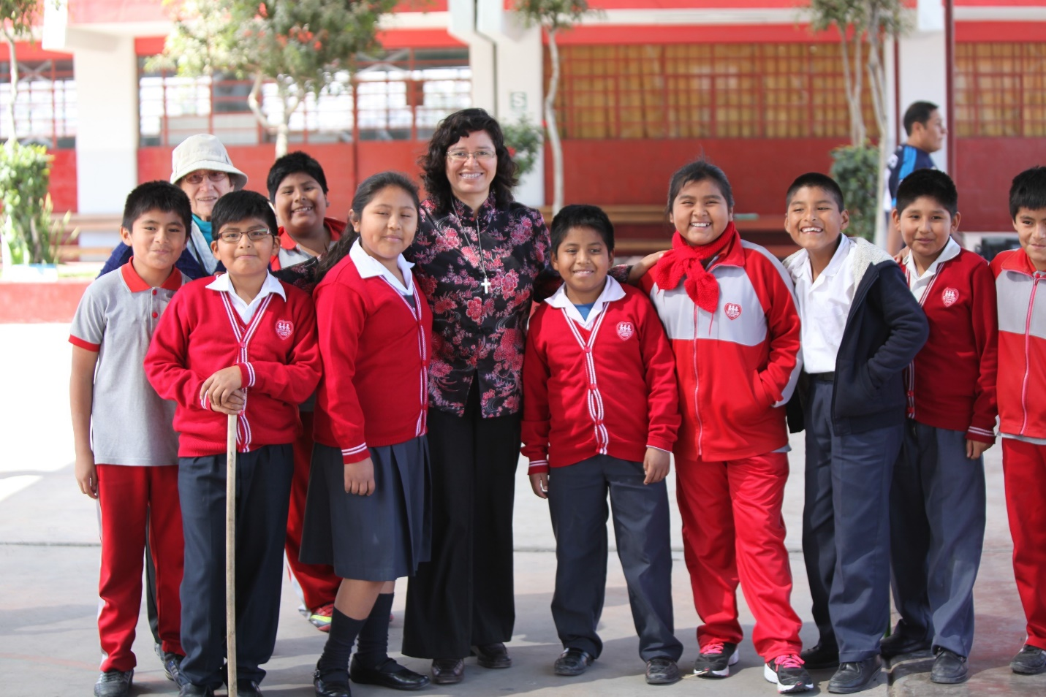
- Srs. Mariá Dolores and Yolanda with students at Faith and Joy School

