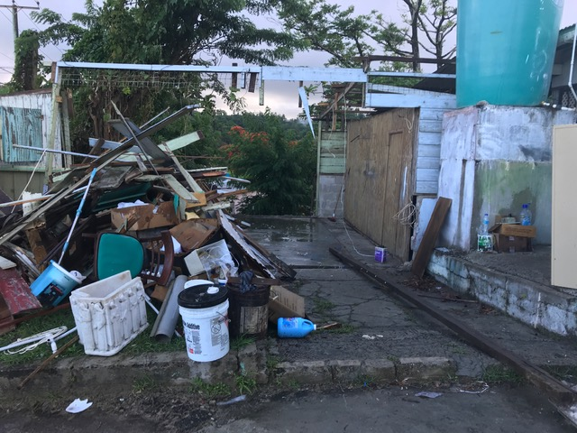

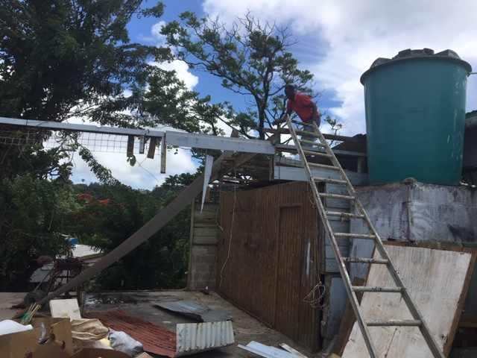

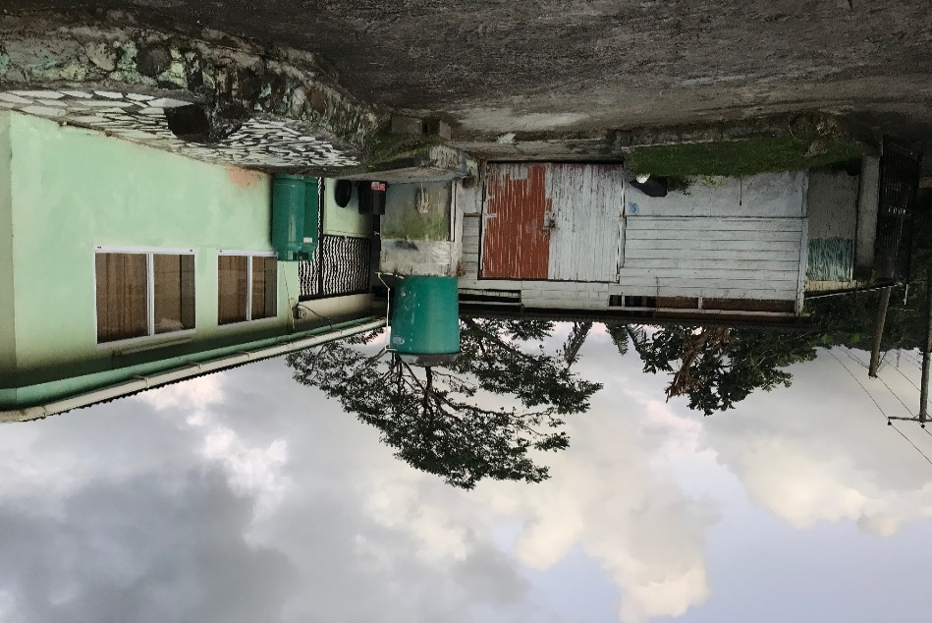

**Proposed location for Presbytery Upgrade**

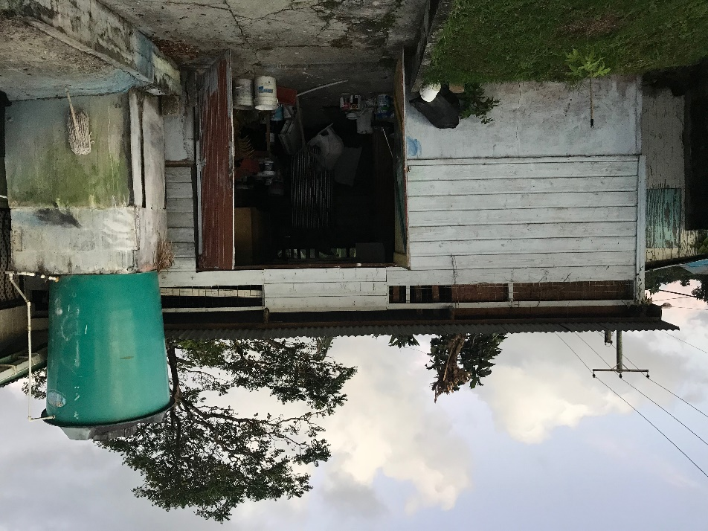

[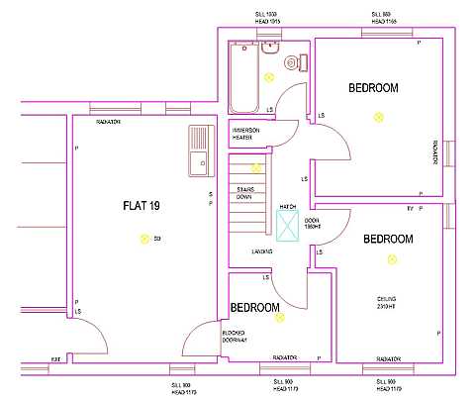](http://www.google.com/url?sa=i&rct=j&q=&esrc=s&source=images&cd=&cad=rja&uact=8&ved=0ahUKEwje2Z7k_LDUAhUDYyYKHROEA3UQjRwIBw&url=http://www.snsm155.com/sm/building-planning-and-drawing.asp&psig=AFQjCNFHzmd8TgP-ITIKhApwOAJxDzYTtA&ust=1497104936012361)