PHOTOS FEATURING SISTER GERMAINE OCANSEY,HHCJ USA MISSION SUPERIOR JANUARY 2014-DECEMBER 31, 2019 AND SECTIONS OF SISTERS IN THE MISSION.
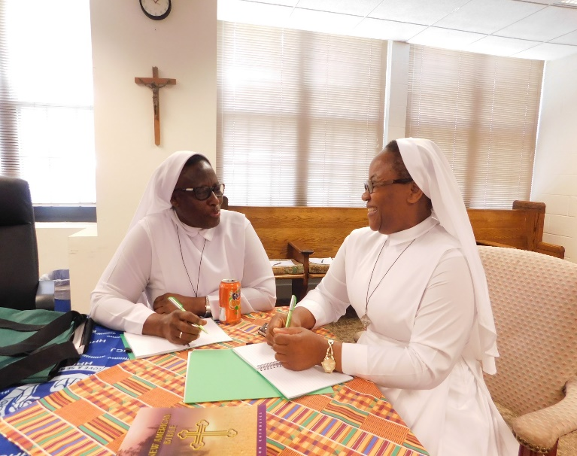
Sister Germaine Ocansey, Mission Superior (left) preparing for a meeting with Sister Henrietta Okoro
(right) her first Councilor.
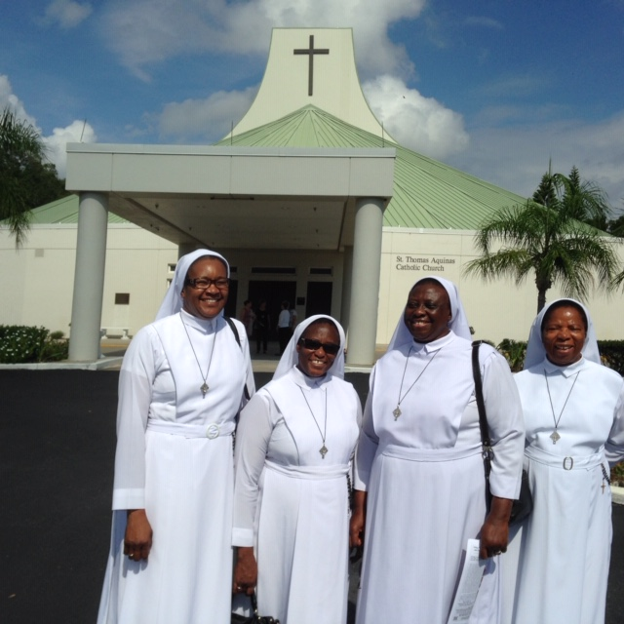
Sister Germaine, (2nd from left) on a visit to the Sisters in New Port Richey Community, Florida (Nov.1, 2015)
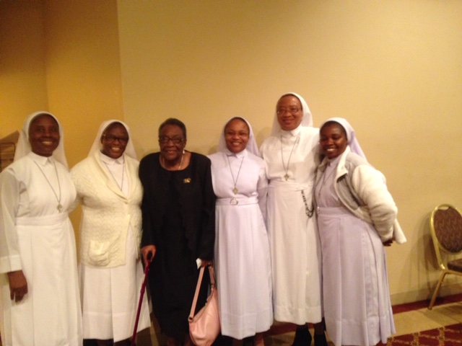
Sister Germaine (2nd from left) on her visit to Tuskegee to visit the Sisters November 8, 2015.
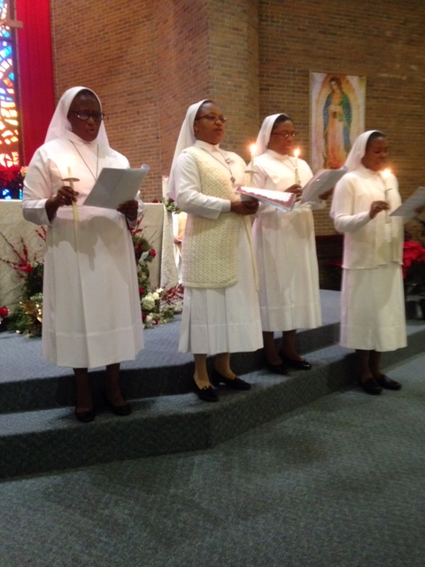
Sister Germaine (Left) with Sisters Henrietta, Catherine Uboh and Emilia Ogar at their Devotional Renewal at the Sacred Heart Parish in Houston Jan 3, 2016
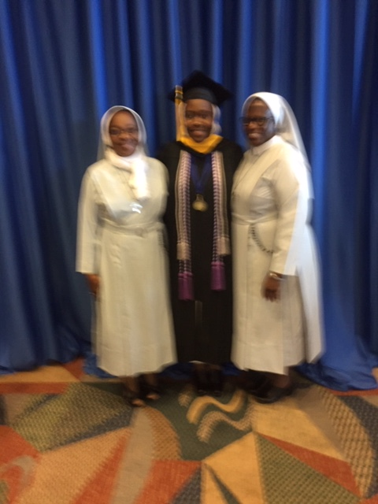
Sister Germaine on the right at the graduation of Sister Gertrude in Omaha, Nebraska in 2017
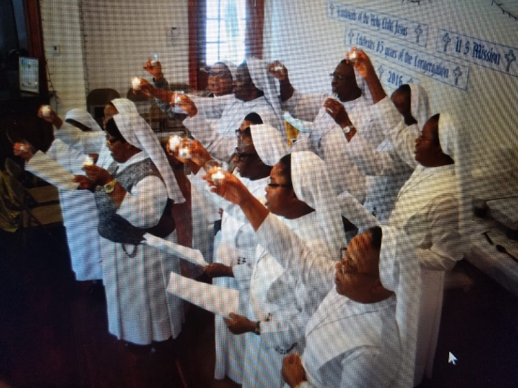
Sister Germaine (Front 3rd from right0 sending forth at the end of our annual retreat in 2018.
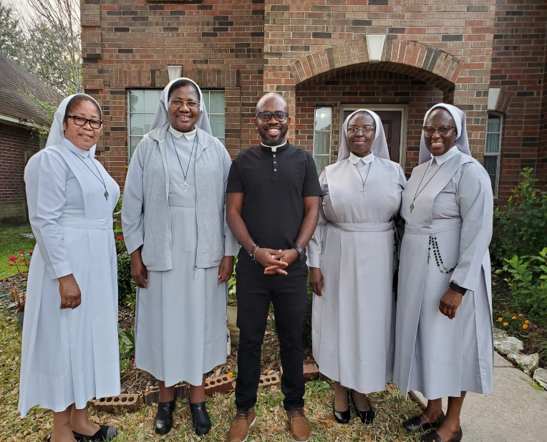
From left to right: Sister Betty Kalu, Mother Leonie Martha O’Karaga – Superior General, Rev. Fr. Jude Ezuma, Sister Elizabeth Anderson, and Sister Germaine Ocansey at far right, November 28, 2019 at Houston.
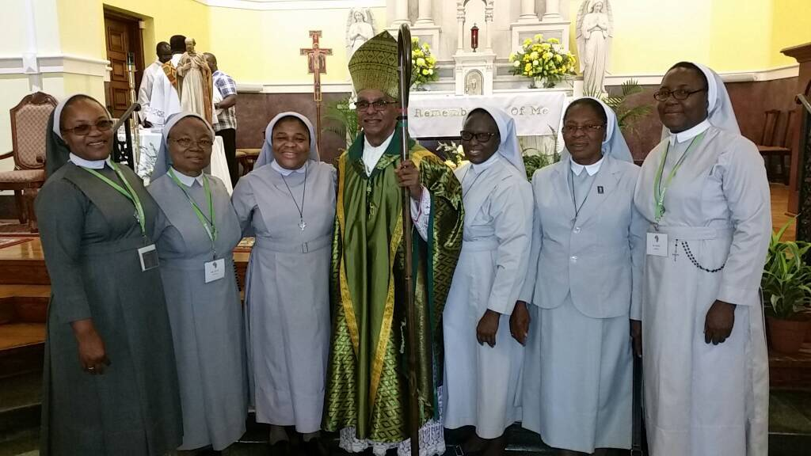
At an African Religious and Clergy Conference in New Orleans with the Bishop in 2017. (3rd from right -Sr. Germaine)
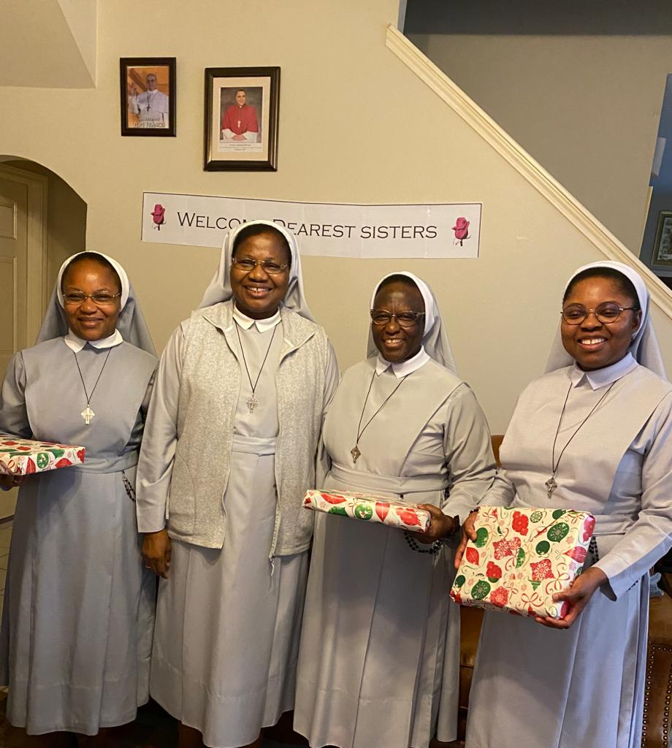
From left to right: Sister Henrietta Okoro, Mother Leonie Martha O’Karaga, Sister Germaine, and Sister Patience Asu – the outgoing Mission Administration with Mother Leonie, 2019.

