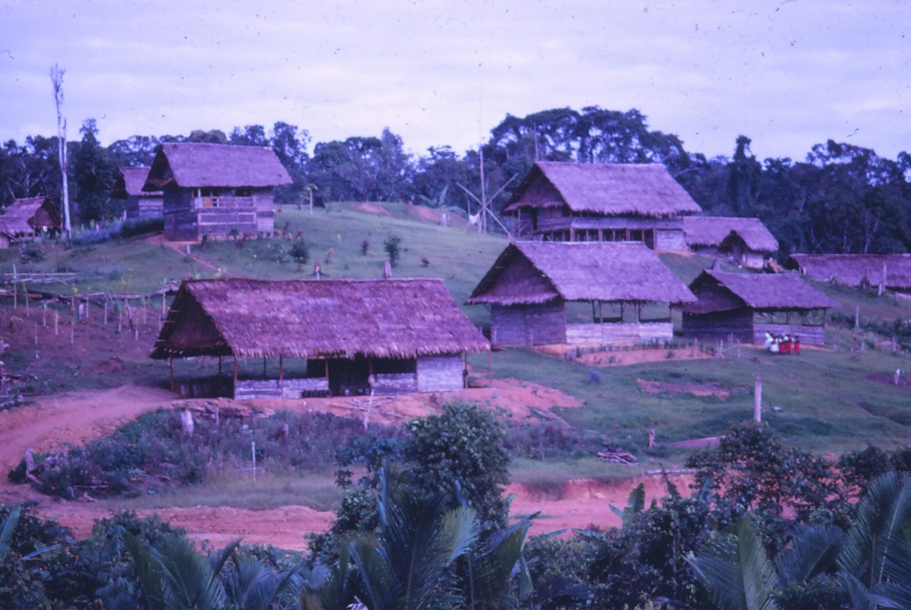

One of the Villages we serve in PNG
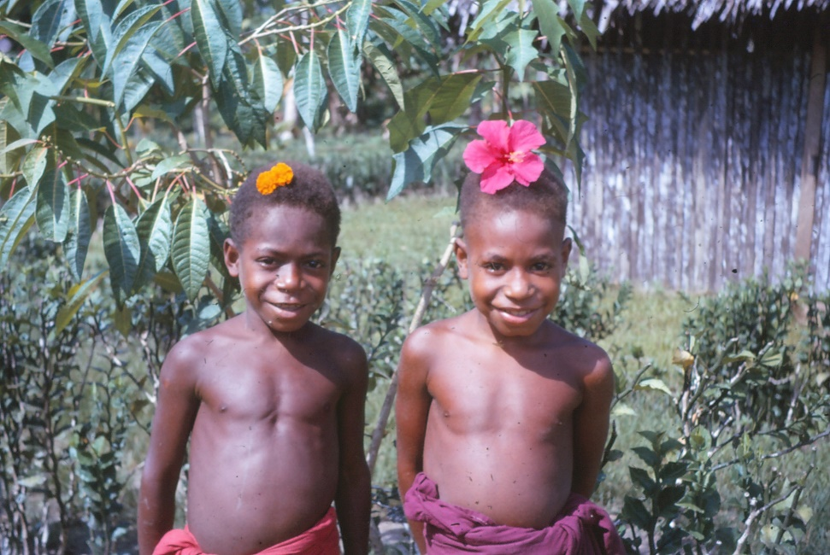
Butter would not melt in their mouths PNG Children love to have their photos taken

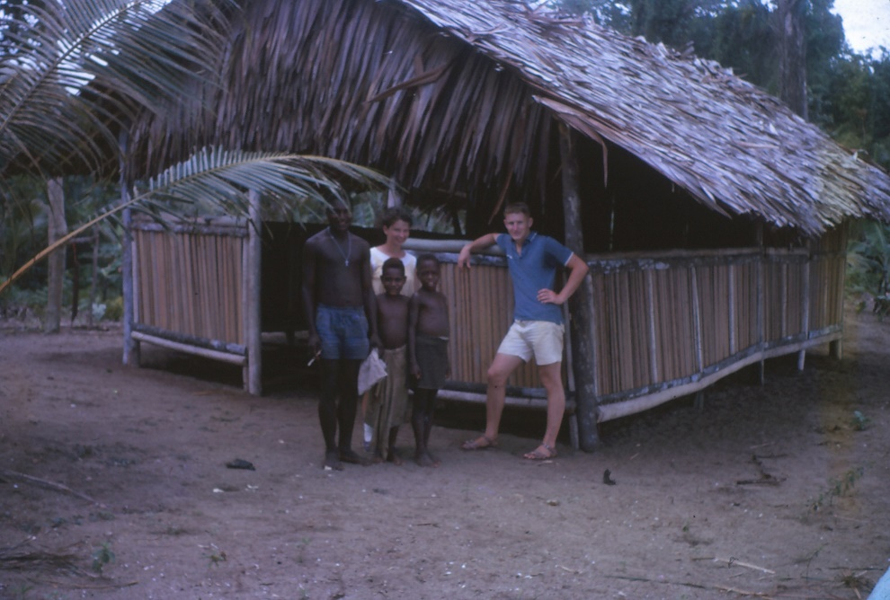
The local Church

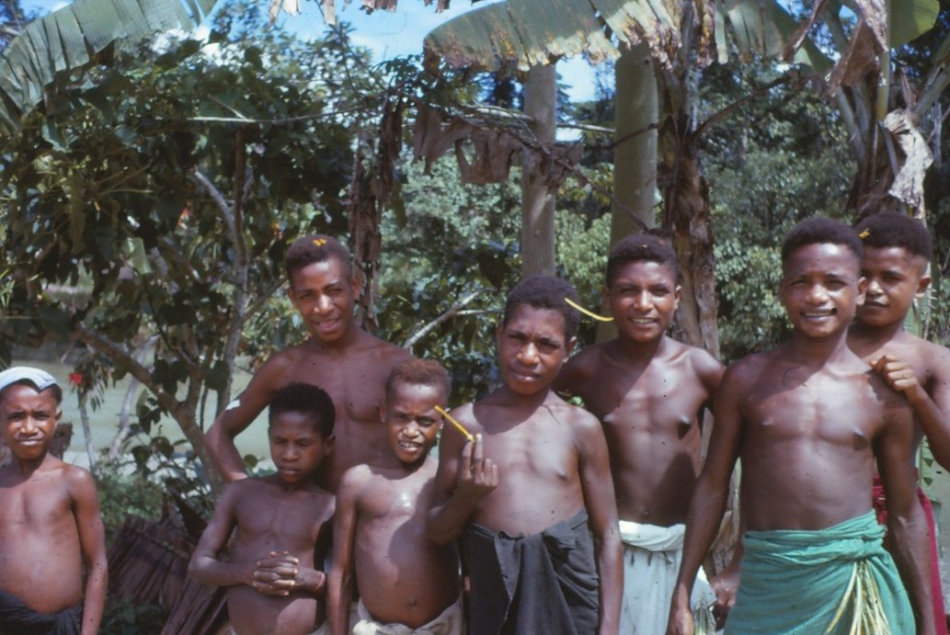
Some of the local girls and boys

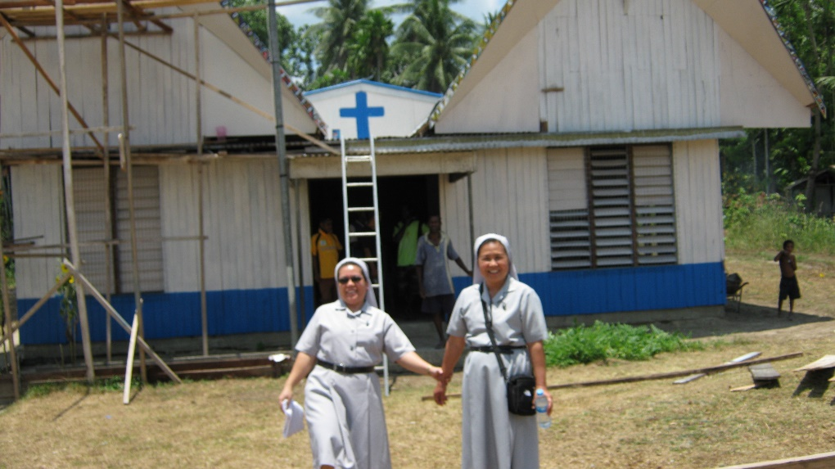
Two of our Sisters outside their Convent
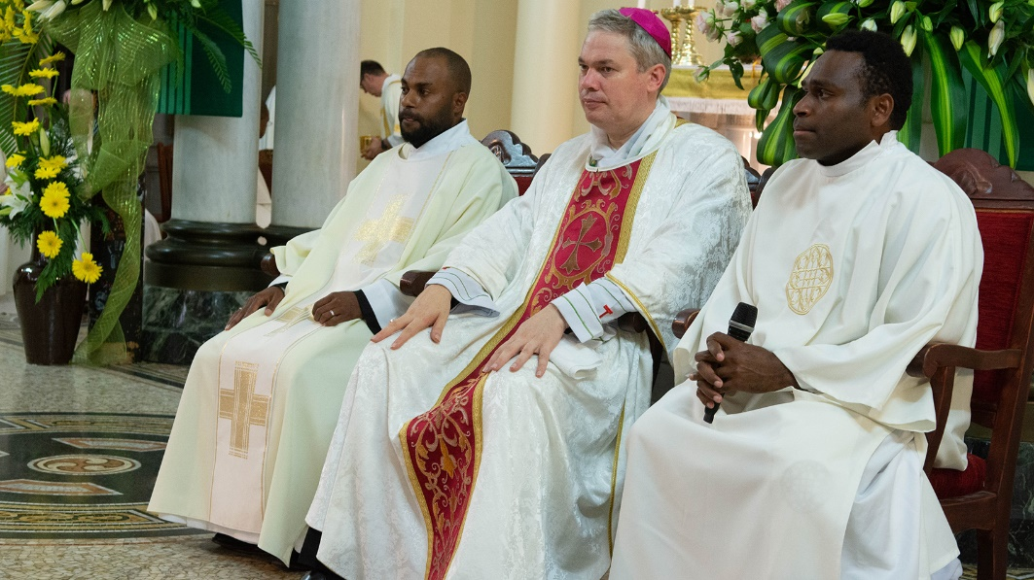
Two of our Students Ordination to Deaconate of two of our PNG Stuydents

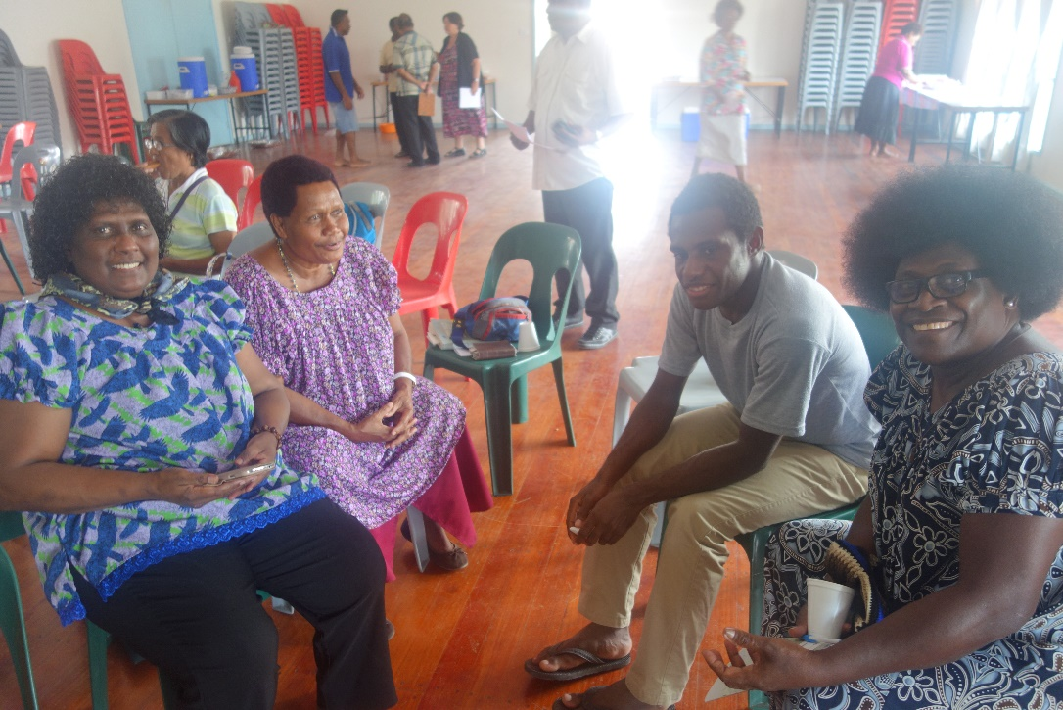
Some of our Lay Catechists

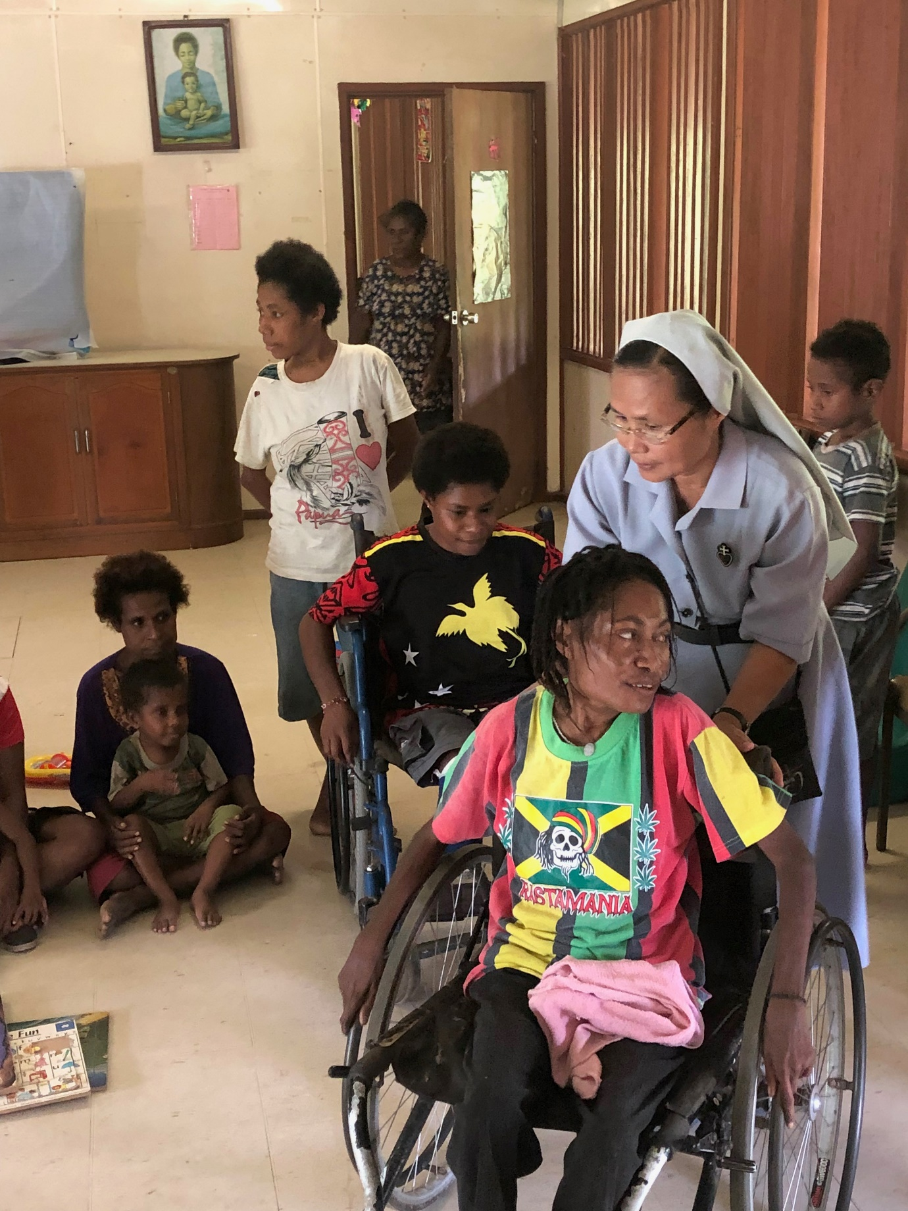
Both Staff and children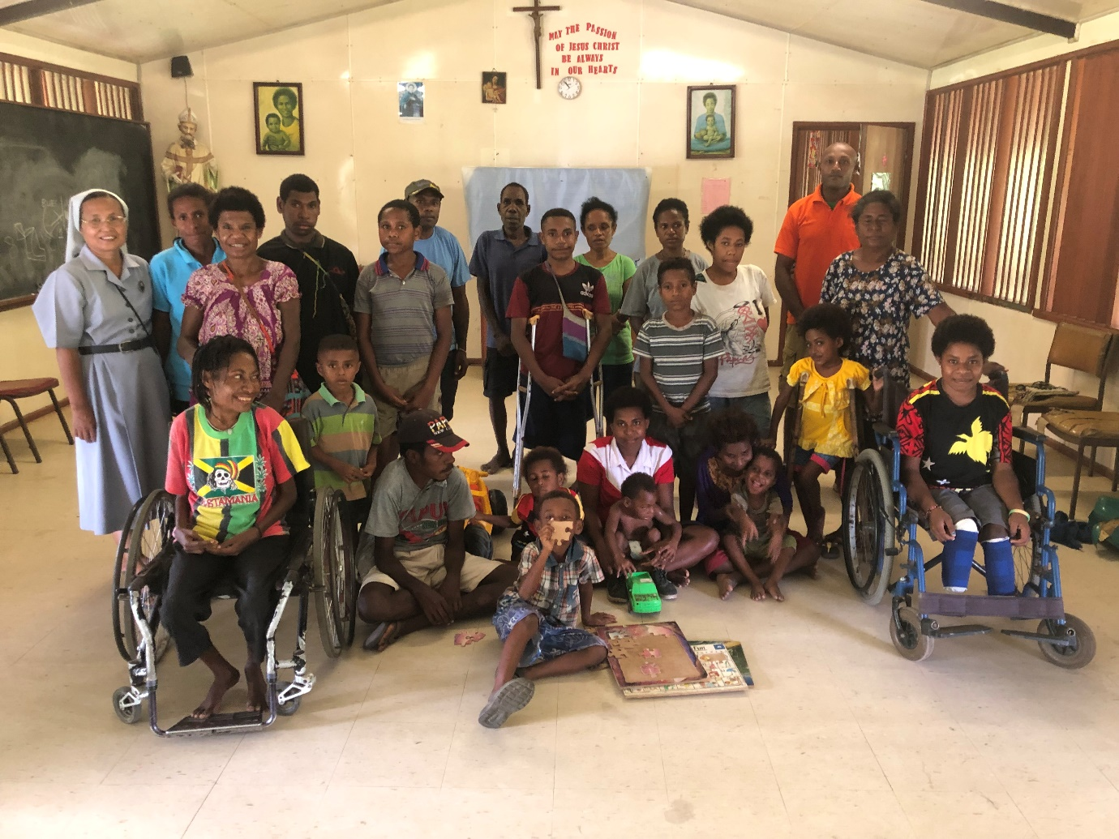Some of the people at Senta Belon Helpn for the children with physical disabilities

