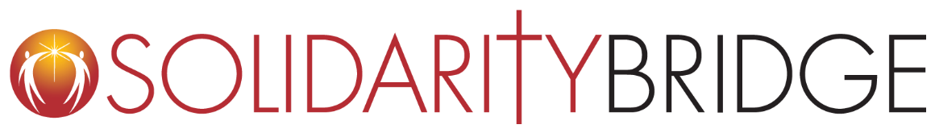

“But five loaves and two fish are all that we have.”
The crowds are too big….We don’t have enough…What are we to do?...
The disciples urge Jesus to dismiss the crowd, lamenting their limitations.
Today’s global healthcare realities can feel much like the scarcity the disciples encountered in this Gospel reading. Five billion people around the globe lack access to safe, affordable surgical care. And 81 million people face catastrophic debt seeking surgical care every year.
But, Jesus is not bound by limitation or scarcity. He does not dismiss the crowd and say, “I’m sorry, but there just isn’t enough.” Instead, he says, “Bring them here to me.” He breaks the bread, shares the meal and ensures that all are fed.
Pope Francis also urges us to not be bound by what we see on the surface. He recently called this an important time to be open to the Spirit, who can “inspire us with a new imagination of what is possible.”
A new imagination of what is possible. For the past 21 years, we at Solidarity Bridge have worked to imagine what is possible for our world and to act from that vision.
Solidarity Bridge is a lay initiative of the Archdiocese of Chicago, responding to the gospel call to heal the sick. We connect medical leaders in the US to their peers in Bolivia and Paraguay to increase access to needed surgery and other essential healthcare. Through focused training, key equipment donations, and strategic partnerships, we are helping the most vulnerable patients access safe and timely surgical care.
Many common illnesses and injuries cannot be solved with a pill. Surgical intervention is often the best course of treatment to alleviate disability and reduce the risk of death from common conditions. Yet in Bolivia and Paraguay where we work, most people cannot access safe and affordable care.
The need is tremendous. It is easy to be tempted by limitations and visions of scarcity. But we know another way is possible. We see it everyday.

Solidarity Bridge works in partnership with medical communities in Bolivia and Paraguay. Together, we operate four year-round programs in general surgery, gynecologic surgery, heart surgery, and neurosurgery. Medical mission trips support these programs, bringing US doctors and nurses to Bolivia and Paraguay to work with local physicians, surgeons, nurses, and other medical personnel. Since 1999, have performed nearly 7,000 surgeries, and delivered care to more than 66,000 patients. By building bridges of solidarity, this mission of healing transforms lives.
We redistribute equipment and supply resources: We help equip talented surgeons in Bolivia and Paraguay, who are deeply motivated to offer the best care to those who have the least access. Since our founding, we have donated over $42 million dollars worth of equipment and, this month a shipping container will arrive in Bolivia, carrying 8 tons of requested medical supplies and equipment.

We promote bi-directional learning and transformation: Our in-depth mission trip preparation invites personal transformation and cross-cultural exchange. Our US medical teams work in a spirit of mutuality and their lives are deeply changed by the relationships they form with their medical peers.
We foster long-term partnerships. Our strength as an organization has come from individuals, parishes, and corporate partners who have dedicated themselves, in a spirit of solidarity, to the health and success of our South American counterparts. Together we've formed a marvelous bridge of solidarity.

TODAY, OUR WORK IS MORE URGENT THAN EVER.
The COVID-19 pandemic is straining the already fragile health systems in Bolivia and Paraguay. And, as patients are forced to delay needed surgeries, their conditions worsen and their procedures become more complex.
The tradition of Catholic social justice teaches that the goods of the Earth are God’s common provision for all. As one human family, we are meant to share equitably in these gifts. In today’s Gospel, Jesus shows the disciples how to ensure that ALL are fed, not just some. This is our mission as church!
At Solidarity Bridge, we seek a world where the health needs of those who are most vulnerable are the priority - where medical professionals have the resources they need to serve their communities. This vision isn’t some far-off dream. It IS possible. It is the call of our faith.
Will you help us continue to make this vision a reality?

