SERVANTS OF THE PLAN OF GOD

The Servants of the Plan of God is a new religious community inspired by the Holy Spirit as an answer to the struggles of this Third Millennium. We are a community of consecrated women who live Full Apostolic Availability, living in religious communities, and giving ourselves to God through evangelization and solidarity in service. In the years since our foundation, by the grace of God, we now have communities and apostolic services in the Americas, Europe, Asia, and Africa.

Formation Center “The Servant of the Lord”

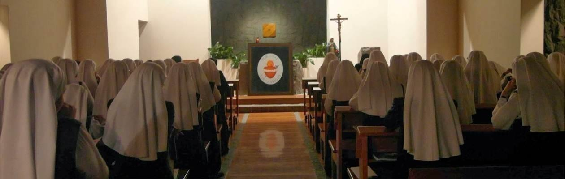
Our Formation Center was created to receive and prepare our novices for their future missions. Our novices receive a comprehensive formation in the areas essential to apostolic missions including spiritual, intellectual, physical, behavioral, psychological, community, apostolic, and vocational development.

At the present time, we have 30 sisters living in the Formation Center and we are experiencing difficulty supporting the financial needs of our Formation Center. We provide food, medicine, clothes, health, health insurance, and the cost of the courses they need for their religious and intellectual formation.

Lima – Peru
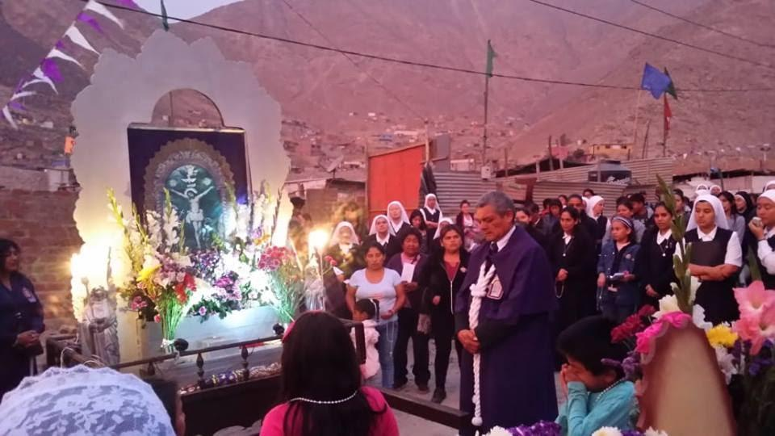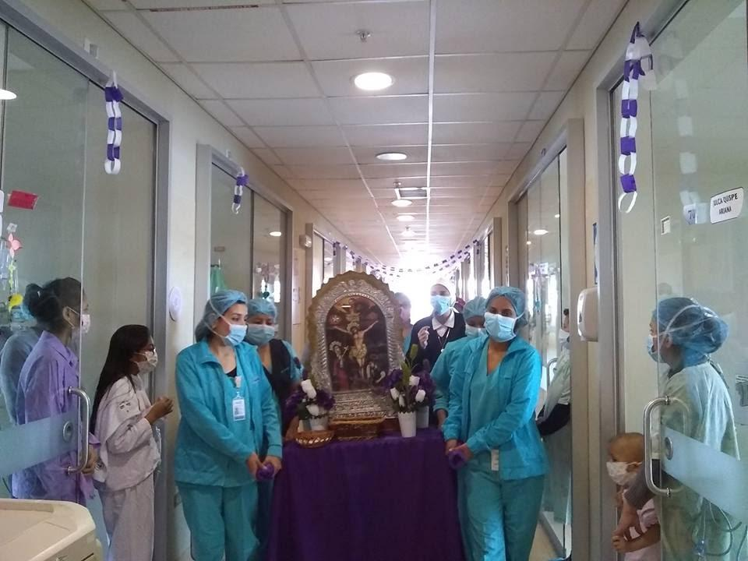

The sisters in our communities located in the Archdiocese of Lima are dedicated to apostolic service and social development, helping in the poorest areas of Lima.

We have a school for handicap children and teenagers with low resources where we assist them with the education and rehabilitation; and we also have a physical rehabilitation center where these children receive physical and psychological care.

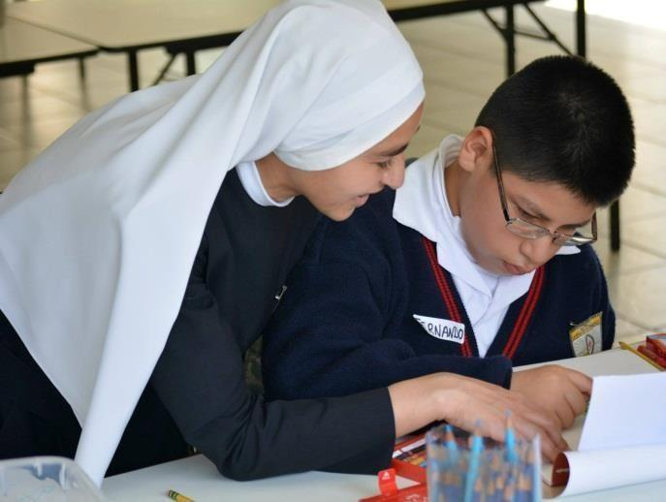
In 2009 we created the service “Joy and Hope” in the Cerro San Cristobal de Lima, in which we provide evangelization services and solidarity with poor people who receive catechetical formation, values, handcraft workshops, and health and hygiene workshops among others to help them improve their living conditions.

Since 2010, our sisters have been giving formation in faith and sacramental catechesis for young people and children of different schools of Lima and since 2012 we have been giving spiritual support for women in prison.

Ayacucho – Peru

During the year 2004, we had the opportunity to open a community in Ayacucho, a region that has been severely impacted by violence and terrorism for more than ten years creating many economic and social needs among the children of God living in this area.

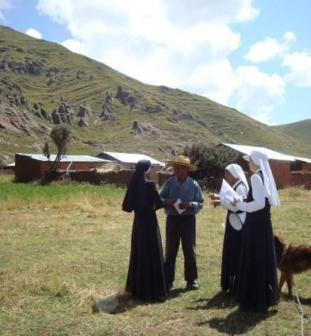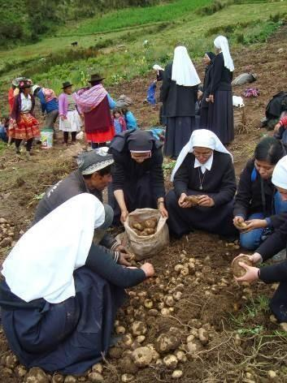
Missions to the villages over 14,000 ft Attetion to andean farmers

In Ayacucho our sisters work in the Archdiocese of Ayacucho giving evangelizing and solidarity service through our apostolate with mission trips and other services such as health care, literacy and educational programs in small villages located far away from the city.

Puno – Peru
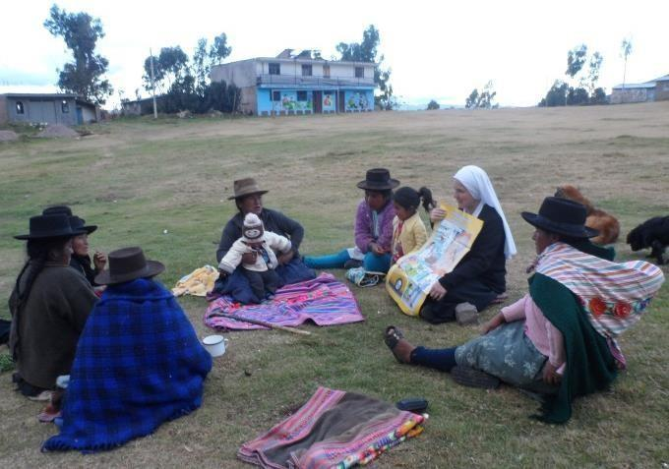
We opened a community in Puno in 2007, invited by Msgr. Kay Schmalhausen Bishop of Ayaviri. Puno is the third poorest area in the Andean region of Peru located at over 13,000 ft. above sea level.
We have a library where children and youth receive educational assistance so they can achieve new skills and grow in learning. We also have solidarity projects to serve abandoned elderly people and the sick in Local hospital.

Medellin – Colombia
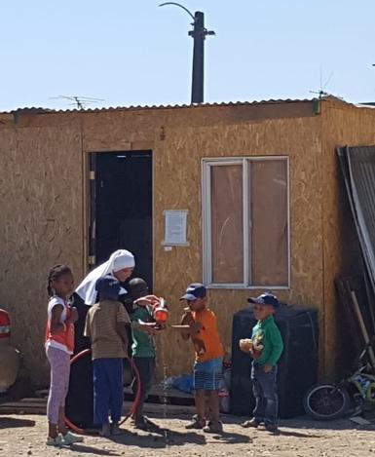
During the year 2002, we opened a community in Colombia, at the Diocese of Sonsón - Rio Negro, which in coordination with the Pastoral labor that the Bishop presides; it is focused on the evangelization of all the countrymen and women of the area including university students. We also have pastoral work with the sick in the local hospitals.

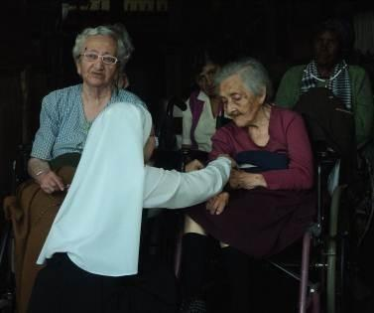
Santiago de Chile – Chile

Also during the year 2002, His Eminence Monsignor Francisco Javier Errázuriz invited us to open a community in the Archdiocese of Santiago, to care for the homeless elderly.

In May 2008, we also opened a new community in Chile that works with the youth and families and in August 2014 we opened a new community to serve the poor in Maipú.

Cebu - Philippines

During the year 2003, Cardinal Vidal invited us to open a community in the Philippines. This community is dedicated to pastoral services and teaching at different schools and they also serve the people through human promotion services in Cebu and mission trips to the Islands around.
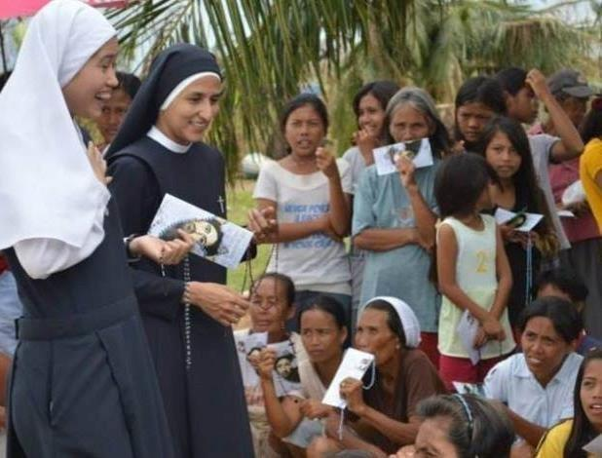
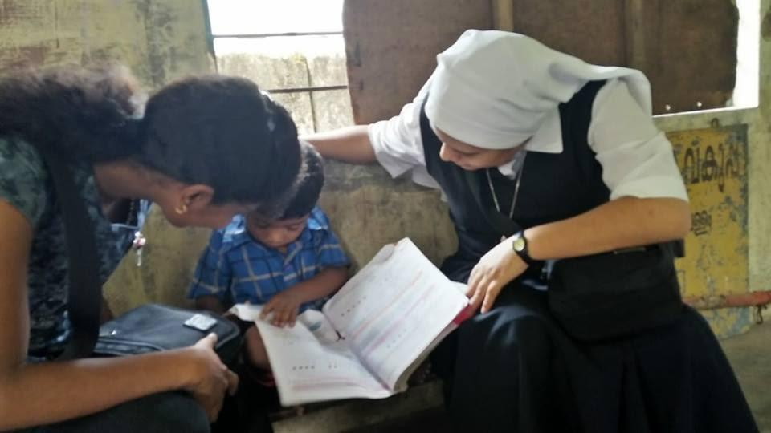

Since 2012 we have had mission trips to the villages in Northern Cebu and also to Tacloban, Leitte; the areas most affected by typhoon Haiyan on 2013. At the present time we are helping people to rebuild their houses and we have projects to help fishermen to recover their boats, to help people to improve crops, to provide medicines etc.

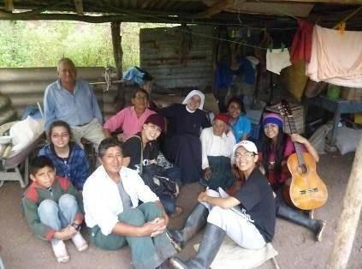
Santiago de Guayaquil - Ecuador

In the year 2004, we open a community in Ecuador which assists young ladies who suffered from mental disease. Also, the sisters take care of the pastoral of Solidarity's
Center in a poor area close to Guayaquil only reachable by canoe. This pastoral and solidarity service is done with young people from different schools and parishes.

Rome – Italy

At the beginning of 2006, we opened a community in Rome, where we are in charge of the pastoral works in a parish working with children, youth, adults and families.

Huambo – Angola

By the grace of God we opened our community in Huambo, Angola, in October, 2005. Sisters help in catechesis to the Archdiocesan pastoral.

Also we have mission trips to small villages that are almost unreachable, where we provide medical and nutritional care, pastoral attention, and literacy teaching.

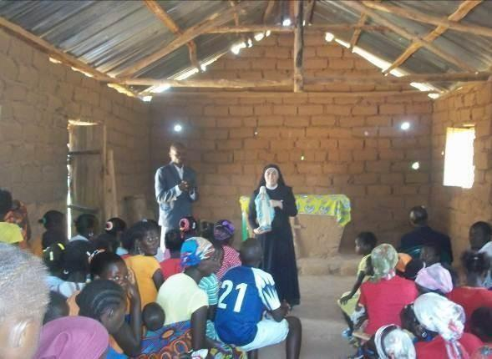
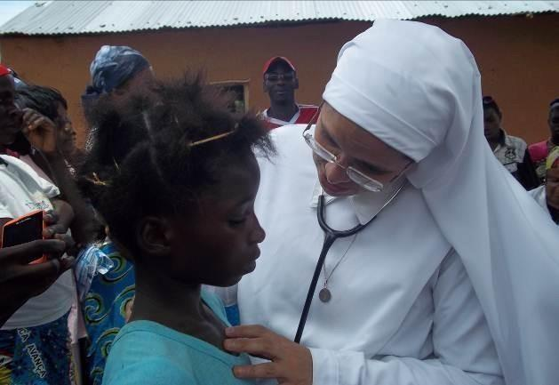
Catechesis for Adults Medical Campaign in a poorvillage

