Varansi Province of the Indian Missionary Society

Prayerful greetings from the Varanasi Province of the Indian Missionary Society, Varanasi, Uttar Pradesh, India.

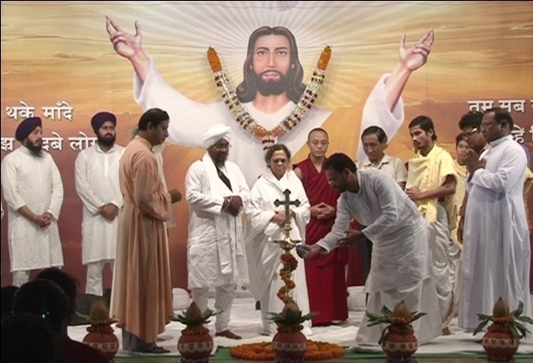
The Indian Missionary Society (IMS) is an indigenous missionary religious congregation started in India in the year 1941. Rev. Fr. Gasper A. Pinto, our founder from south India, came to Varanasi, the Rome of Hinduism, to start a new religious congregation with the sole aim to spread the Gospel message to areas where Christ is not known. He was well aware that the foreign missionaries of this area would be asked to go back once India got independence. Today the Indian Missionary Society has two provinces and a region working in most parts of North India.
Being a missionary congregation we do not get any support from the local communities because all of them are either Hindus or Muslims. The existing small Christian community, being poor and marginalized, depends on us for support. IMS has so far relied upon God’s providence and the generosity of our benefactors. The support we receive from various like-minded organizations and benefactors is a great contribution for our missionary work.
We do not have any major income- generating institutions.
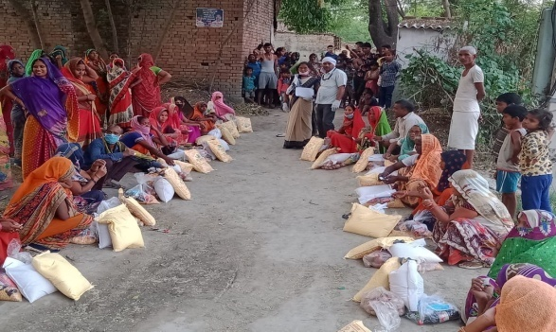
All our missionaries work in the remote areas of rural India. By your prayers and financial help you and your parish becomes part of our effort to share the Good News of Jesus. You can be sure of our regular prayers for the parish. I take this opportunity to thank you for the help and support your parish will provide to our religious congregation for the spread of the Good News and other Humanitarian works.
COVID-19 RELIEF WORK

With prayerful regards,
Rev. Thomas John Valiaveetil IMS.
Provincial Superior/ President.
Varanasi Province of the Indian Missionary Society.

