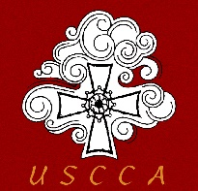
US-China Catholic Association

Parish Bulletin Announcement - Option A

About the Church in China and the US-China Catholic Association (USCCA)
Next / This Sunday we will be taking a collection for the US-China Catholic Association.

Few realize that China has over 12 million Catholics. They live under strict government regulation, yet under these repressive circumstances they continue to witness to their faith and serve their church and society.

All recent popes have emphasized the vital importance of the Church's mission in China. Pope Francis was able to reach a difficult – and sometimes misunderstood – agreement regarding the appointment of bishops in China. This is a vehicle to build trust and promote dialogue.

Through its website, newsletter, various speaker series, study tours in China, and biennial national conferences, the USCCA provides the American public with balanced information concerning the circumstances of the Church in China. In collaboration with affiliate organizations, it is developing programs for lay ministerial training, outreach to Chinese studying in the United States, translation of religious and devotional literature, and the provision of informational materials regarding Catholicism in China for Americans traveling there.

The USCCA is the only national Catholic nonprofit dedicated to linking the U.S. Church with Catholics in China. You can learn more at www.USCatholicChina.org.

US-China Catholic Association

Parish Bulletin Announcement - Option B

About the Church in China and the US-China Catholic Association (USCCA)
Next / This Sunday we will be taking a collection for the US-China Catholic Association.

Few realize that today in China there are some 12 million Catholics, according to official estimates, more according to other sources. While Catholics constitute a small percentage of China’s overall population, they have a long and vibrant history.

The US-China Catholic Association exists to promote mutual understanding, friendship and exchange between Catholics in the United States and Catholics in China. Founded in 1989 through the collaborative efforts of Maryknoll, the Jesuits, other religious orders, and the US bishops, today the China Association represents a cross-section of American Catholic organizations and individuals working in partnership with Catholics in China to advance the mission of the Church in our world today.

Through its website, its newsletter, various speaker series, and biennial national conferences, the USCCA provides the American public with balanced information concerning the circumstances of the Church in China. It also runs study tours in China so that Americans can have firsthand experience of the reality of Chinese society and the Chinese Church. In collaboration with affiliate organizations, it is developing programs for lay ministerial training, translation of religious and devotional literature, and the provision of informational materials regarding Catholicism in China for Americans traveling abroad.

It’s latest efforts, the Campus Ministry Outreach Initiative, is designed to help, among others, Campus minsters and teachers, better understand the over 400,000 Chinese international students attending U.S. high schools and universities to provide opportunities for deeper understanding, mutual exchange, and friendship, and ultimately, share the Gospel message to take back to China.

All our recent popes have emphasized the vital importance of the Church's mission in China. Saint Pope John Paul II constantly sought to strengthen the faithful in China. Pope Benedict XVI wrote a milestone pastoral letter to the Chinese Church to provide guidelines under difficult circumstances. Pope Francis was able to reach a difficult – and sometimes misunderstood – agreement regarding the appointment of bishops in China. This is a vehicle to build trust and promote dialogue.

You can learn more about the USCCA and its programs at www.USCatholicChina.org.

US-China Catholic Association

Parish Bulletin Insert Option C – One-page Insert

One-page insert follows on the next page. This is also available as a PDF

An example of a possible one-page insert follows on the next page.

U

US-China Catholic Association

Mission Appeal

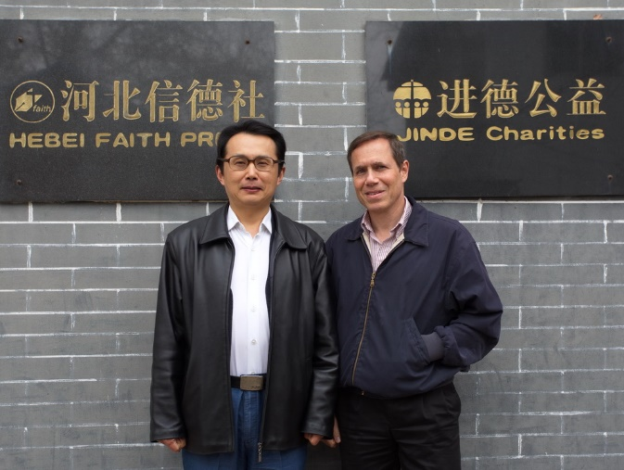
Today in China there are some 12 million Catholics, according to official estimates, more according to other sources. The US-China Catholic Association exists to promote mutual understanding, friendship and exchange between Catholics in the United States and Catholics in China. Founded in 1989 with through the collaborative efforts of Maryknoll, the Jesuits, other religious orders, and the US bishops, today the China Association represents a cross-section of American Catholic organizations and individuals working in partnership with Catholics in China to advance the mission of the Church in our world today.
Fr. Michael Agliardo and Fr. JB Zhang, founder of Faith Press and Jinde Charities (the Catholic charities of Hebei Province).

Currently, the Chinese government has launched a drive for all religions to limit outside influence and conform to Chinese ways of doing things. Priests operate throughout the country under the strict supervision of the Chinese authorities. These policies have exacerbated the tensions under which Catholics in China live their faith.

In this context, the USCCA provides the American public with balanced information concerning the circumstances of the Church in China through its website, its newsletter, various speaker series, and biennial national conferences. It runs study tours in China so that Americans can have firsthand experience of the reality of Chinese society and the Chinese Church. In collaboration with affiliate organizations, it is developing programs for lay ministerial training, translation of religious and devotional literature, and the provision of informational materials regarding Catholicism in China for Americans traveling there.
Missionary Sisters of Our Lady of Hope in front of the retreat center they built.

This year, in particular, we were able to promote networking between Catholic organizations in China and the U.S. in response to the Covid-19 pandemic.

At present w

e are engaged in a new effort, the Campus Ministry Outreach Initiative. Currently over 450,000 Chinese international students study at U.S. high schools and universities. In view of this reality, the China Association is working with partners to assist teachers, professors, counselors, and campus ministers better host and engage these young people to provide opportunities for deeper understanding, mutual exchange, and friendship, and ultimately, share the Gospel message to take back to China.

We trust that the seeds of faith and friendship that we plant will, with the nurture of the Holy Spirit, bear fruit in the lives of these young people. It is they will go on to make a difference in China and the world in the years ahead.

All our recent popes have emphasized the vital importance of the Church's mission in China. Saint Pope John Paul II constantly sought to strengthen the faithful in China. Pope Benedict XVI wrote a milestone pastoral letter to the Chinese Church to provide guidelines under difficult circumstances. Since his accession, Pope Francis has reached out to Chinese leaders in fraternal charity, recently concluding an agreement regarding the appointment of bishops in China.

Find out more about the vital mission of the USCCA by visiting: www.USCatholicChina.org

