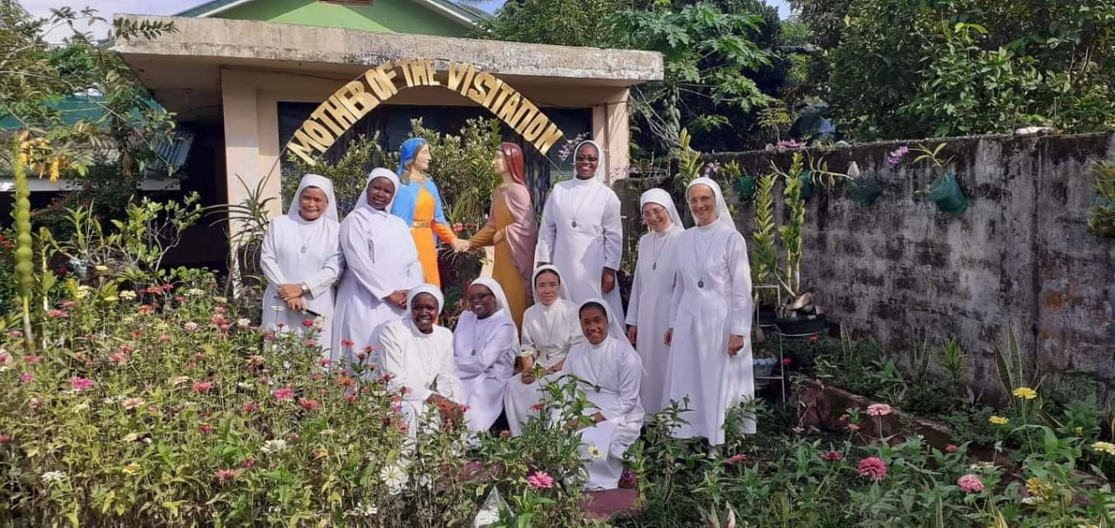

SISTERS SERVANTS OF THE VISITATION
The Congregation of the Sister Servants of the Visitation Foundation Incorporated is an international missionary Congregation, founded in 1978 by Mother Vincenza Minet in Assisi, Italy. It is a young Congregation, and at present serving on five Continents: Europe, South America, Asia, Africa, and Australia. The charism of the Congregation is to renew the visit of Our Lord to humanity; to live and transmit to others, like Mary, the joy of salvation to all and to serve with particular care the most vulnerable and the most needy.
LOVE
Where the SSVFI Congregation is present, the Sisters commit their lives to caring assistance for the sick, special needs children, and impoverished individuals and families whom God brings to their door.
The Mission Home in Borongan, Eastern Samar, Philippines devotes particular care to children who are malnourished, neglected, orphaned, physically or mentally disabled, victims of violence, children of jobless single mothers, and children of the incarcerated. The Sisters provide the love and security fundamental to development of healthy individuals.
JOY
The Mission was opened through the grace and intervention of God, when Mother Foundress met the late Monsignor Angelo Saverio Zanisi in Borongan in 1988. Msgr. Zanisi asked for the assistance of the SSV Sisters to expand his mission of providing medical aid to the poor of Borongan. The benevolent priest purchased a house and lot to serve as a convent for three Italian SSV Sisters. The convent served as a temporary shelter for two malnourished minors who were taken into the sisters care. The charity work of the missionary Sisters eventually reached out to the nearby communities. With the help of Divine Providence, a residential facility was built for the continued purpose of caring for the neglected poor.
​SERVICE
​SSV programs assist patients in the Provincial Hospital, especially those in critical situations. They offer programs for short-term and long- term care for severely malnourished children at their residential care home and a nutrition program for children living with their families. These programs provide food, supplements and continued monitoring of children through a schedule of home visits until the children fully recover their health. SSV also sponsors a scheduled feeding program for the children who are living in upstream areas of Borongan. There the SSV Sisters make home visits to the very poor. Their educational outreach programs sponsor children in their studies with needed tuition, books, backpacks, transportation, allowance for school lunch and snacks. The Sisters are also trying to help families augment their income by providing livelihood training and some financial assistance to improve the economic security of the family. Their plans are not yet fully realized because of the lack the financial resources to grow these programs. The Guardians of the Visitation and the SSV Sisters wish and pray to improve current programs and to extend all their services to other remote areas of Eastern Samar.

GUARDIANS OF THE VISITATION
guardiansofthevisitation.org

