The Fervent Daughters of the Sacred Heart of Jesus
Our religious community of women, called "The Fervent Daughters of the Sacred Heart of Jesus", was founded by Rev. Sr. Marykutty FDSHJ in 1981, who was deeply devoted to the Sacred Heart of Jesus. The community that started with 12 members has grown now to a size of 162 nuns. We live as 40 units and serve in the rural areas of many states of India, such as Kerala, Assam and Thamilnadu. We practice devotion to the Most Sacred Heart of Jesus by way of Perpetual Adoration to the Blessed Sacrament, Family Apostolate, and Social Ministry to the poor. We have two major projects and needs: support for our home for vulnerable women with down syndrome and physical disability, which provides professional care and spiritual hope, and the continued education and formation of our members who enter the religious life with only basic education.
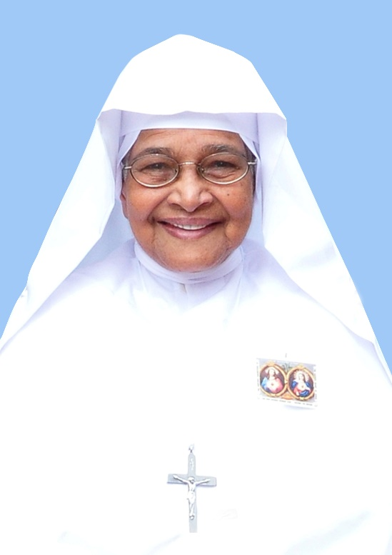
Mother Founderss Sr.Marykutty Puthuparampil FDSHJ (1937-2014)

