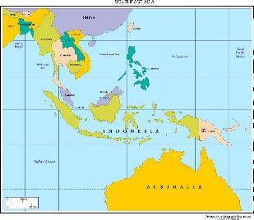
Bulletin Announcement

The map shows where PNG lies in relation to S.E. Asia and Australia

Congregation of the Passion- Holy Spirit Province
Next Sunday there will be an appeal for the Missions. One such missionary Congregation which the Archdiocese of Chicago is supporting this year is the Passionist Congregation – which comprises of Sisters, Brothers and Priests. They work Papua New Guinea (PNG) with Handicapped children, Seminarians, Refugees, and in two parishes one in Vanimo - in the N.W. corner of PNG - and the other in Port Moresby

Currently, we are trying to raise money to build a training house for our students in PNG and most importantly support the work at our Centre for handicapped orphaned children. We have ten students at the moment and need to provide accommodation for them. Our Centre for the children receives no outside support except what the Appeal raises It cost AUS$15000 a year to run.

As well as all this, there is an urgent need to train and to provide resources for our Catechists who form a vital part of our Mission. In fact these Catechists people are the backbone of our Mission for without them we simply could not function. Our latest work is trying to offer protection to women and children who are victims of Domestic Violence which, unfortunately, is of pandemic proportion in PNG where women are seen as worthless and good for nothing. They are beaten very regularly by men and boys. Our mission urgently need money to build a shelter for these women.

Thank you for your prayers and finical contribution to the Missions. I assure of prayerful remembrance in the prayers and Masses of the people of the Missions in PNG. May God bless you all

