A Short History of the Comboni Missionaries

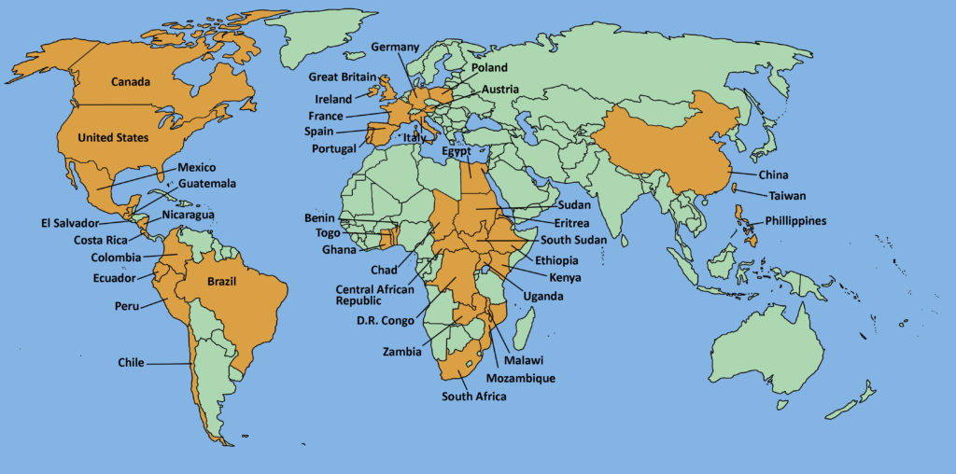

More than 4,000 priests, brothers, sisters and lay people form the Comboni Missionaries, a group of men and women committed to announcing the Gospel and serving the poorest and most abandoned people in more than 42 countries in Africa, Asia, Europe, Latin America, and North America.

The Comboni Fathers founded a community in LaGrange Park in 1985, and have ministered for the Chicago diocese ever since. Currently, we minister and assist in parishes, nursing homes, as Chaplain to the Sisters of St Joseph, and as ministering in a special way to the Hispanic community. We also have Comboni Sisters in Virginia and Baltimore working with the poor. The Comboni Lay Missionaries Program is another way we continue that work today. This program began in the U.S. in 1994 and is also located in La Grange Park, Illinois, and we prepare lay missionaries for overseas assignments.

The Comboni Missionaries Provincial House is in Ohio, and we have responsibility for a parish there. In New Jersey we have a parish and a mission center, and there are two more parishes in California, and a mission center there. As you can see, the Comboni Family is not just “visiting” here in Chicago. We are part of the community here, and of the Church in the US.

For St. Daniel Comboni, the key elements of missionary methodology include respect for the culture and natural religious expression of the people they serve. We join with the local community, living a simple life-style, showing solidarity with the least of all, and being the prophetic voices of the voiceless.

